

Department of Artificial Intelligence
Course Title: Data Mining

LAB MANUAL

Submitted To:
Mr. Arham

Submitted By:
Ayesha Imran 2023-BS-AI-057

Table of Contents
Lab 1: KNIME Introduction 3
Lab 2: Customer Churn Prediction 12
Lab 3: Data Cleaning 18
Lab 4: Data Preprocessing 23
Lab 5: Market Basket Analysis 30
Lab 6: Apriori Algorithm (Product Combination Analysis) 35
Lab 7: FP-Growth (Efficient Frequent Pattern Mining) 40
Lab 8: Python Basics (Reusable Data Processing Module) 45
Lab No 9: Decision Tree 50
Lab No 10: Naïve Bayes & K-Nearest Neighbors (KNN) 57
Lab No 11: Support Vector Machine (SVM) for Credit Card Fraud Detection 62
Lab No 12: Customer Segmentation 70
Lab 13: Outlier Detection 83
Lab 14: Scraping & Sentiment Analysis 85
Lab No 15: Final Capstone – End-to-End Business Solution 88

Lab 1: KNIME Introduction
Real-World Scenario
A retail company stores large volumes of transaction records from different product categories. Although the data is available, it cannot support decision-making unless it is organized and examined properly. Business managers require clear analytical outputs to measure overall sales revenue, estimate average customer purchase value, identify the categories generating the greatest earnings, and determine which individual products produce the highest profit contribution.
This practical task uses KNIME Analytics Platform to transform raw retail sales data into useful business intelligence through a workflow-based analytical process.

Dataset Description
The dataset applied in this exercise is a Retail Sales CSV file containing detailed transaction records.
Each row represents one completed sale and includes fields such as:
- Transaction ID
- Product Title
- Product Category
- Quantity Sold
- Unit Price
- Purchase Date
- Sales Amount (or Revenue generated during processing)
The dataset is suitable for performing summarization, revenue calculations, category comparisons, and product ranking analysis.

Software Tool Used
KNIME Analytics Platform
KNIME is a visual analytics software that allows users to create data workflows by connecting functional nodes. Every node is responsible for a specific task such as importing files, cleaning data, changing data types, calculating formulas, generating summaries, or performing aggregations.
When combined, these nodes build a complete data analysis pipeline that converts unstructured sales records into valuable managerial insights.
Practical Learning Outcomes
After completing this lab activity, students will be able to:
- Load a CSV sales dataset into KNIME using the CSV Reader node.
- Inspect and adjust column data types for accurate processing.
- Produce descriptive statistics to understand the nature of the dataset.
- Create a new Revenue field using the Math Formula node.
- Analyze four major retail KPIs using GroupBy and Sorter nodes.

Procedure
Step 1: Download the Dataset
Obtain the Retail Sales dataset in CSV format from the provided source and save it locally for analysis.
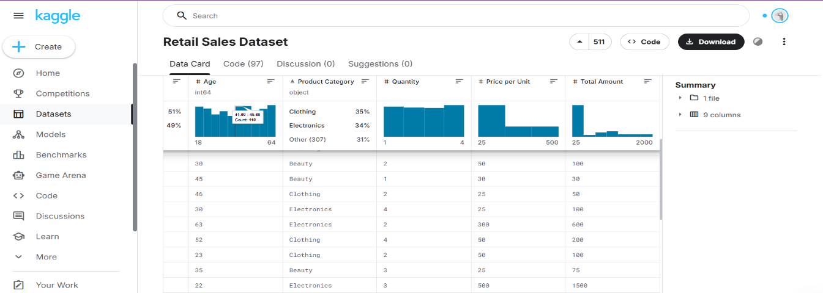
Step 2: Create a New Workflow
Launch KNIME Analytics Platform and create a new workflow named Retail Sales Analysis to organize the analytical process.
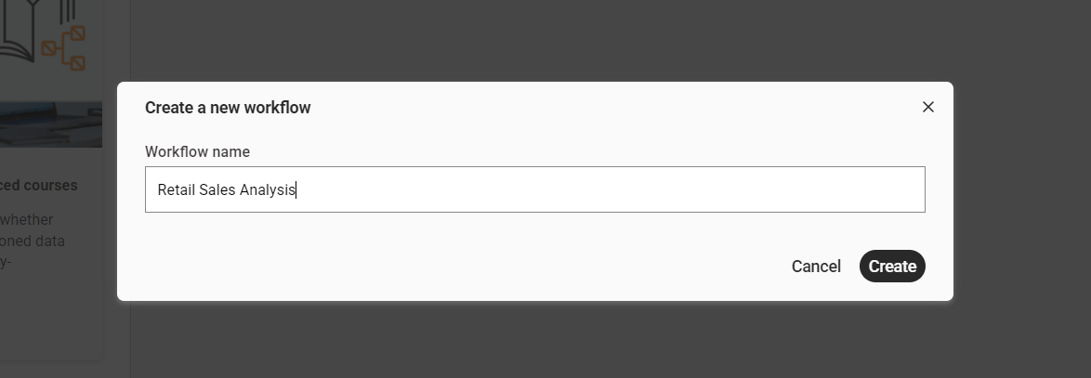
Step 3: Import the Dataset
Use the CSV Reader node to load the Retail Sales dataset into the workflow environment and verify successful execution.
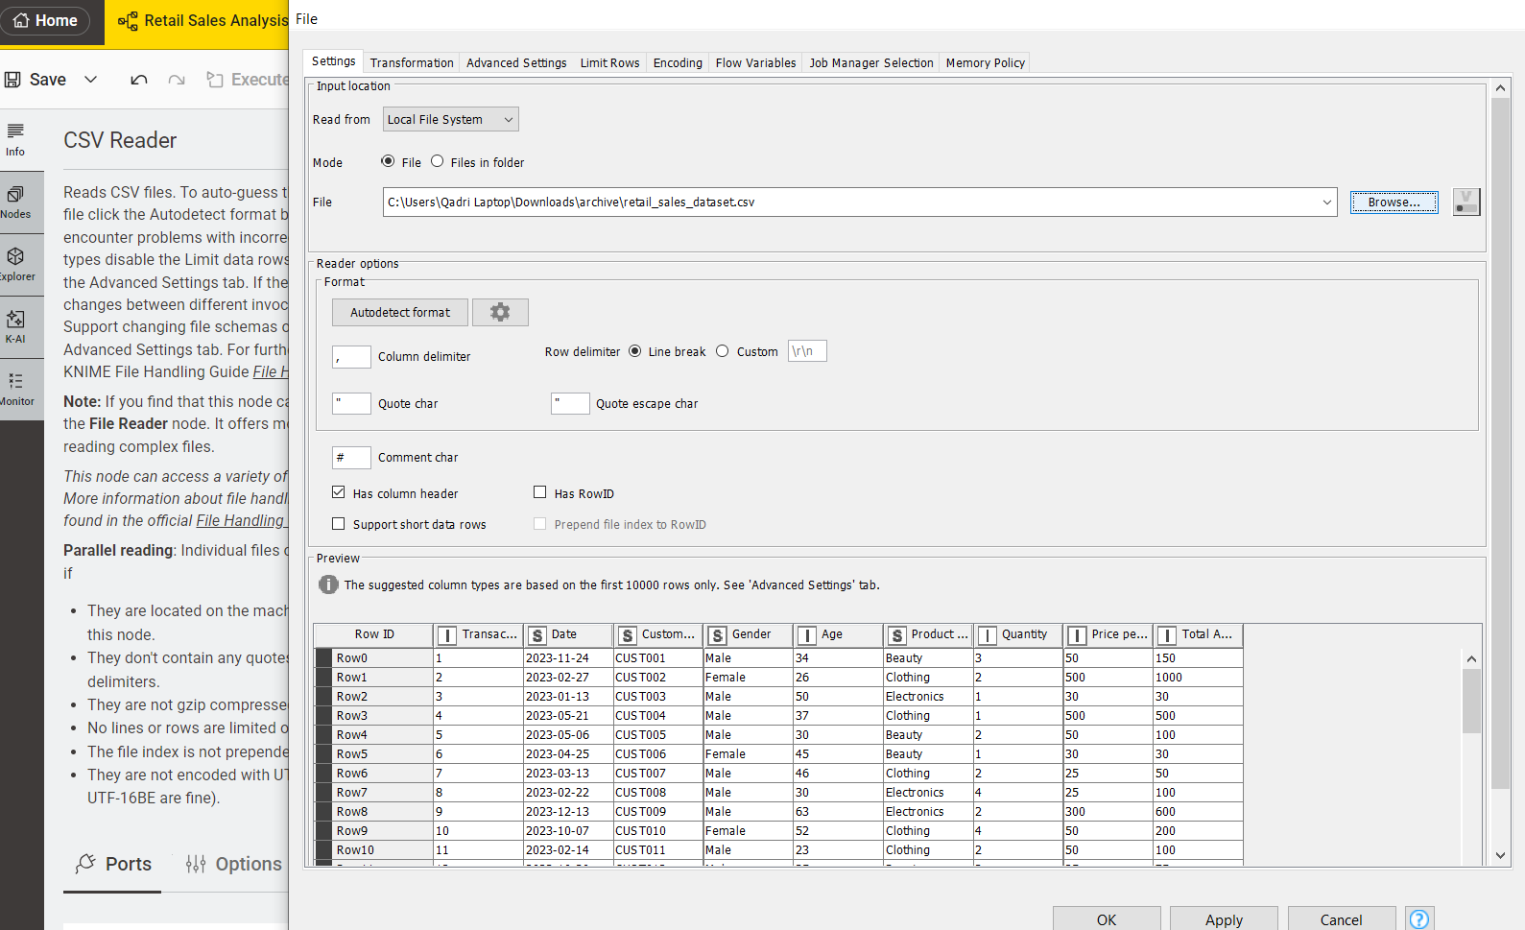

Step 4: Verify the Data Types
Inspect all columns to ensure numeric fields (Quantity, Price, Revenue) are correctly typed as Integer or Double, and categorical fields (Category, Product Name) are set as String.
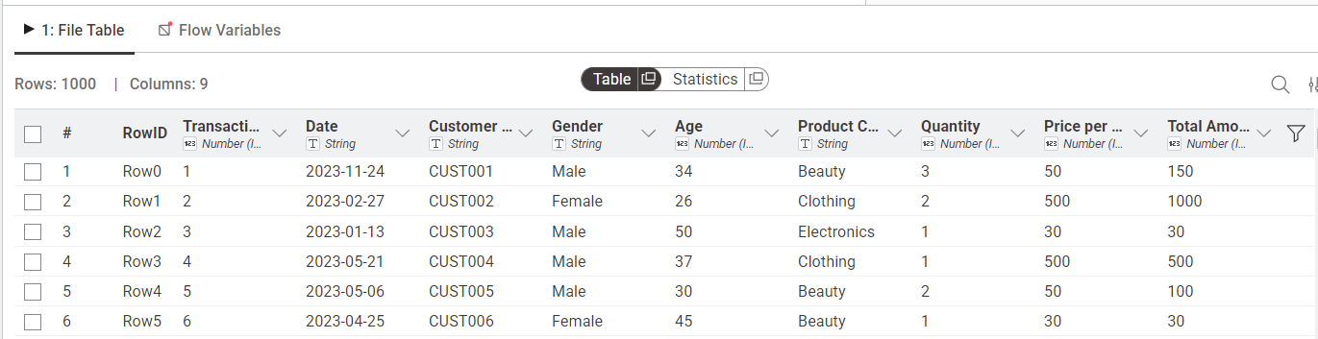

Step 5: Generate Summary Statistics
Apply the Statistics node to compute descriptive measures such as mean, minimum, maximum, sum, and standard deviation for numeric attributes.
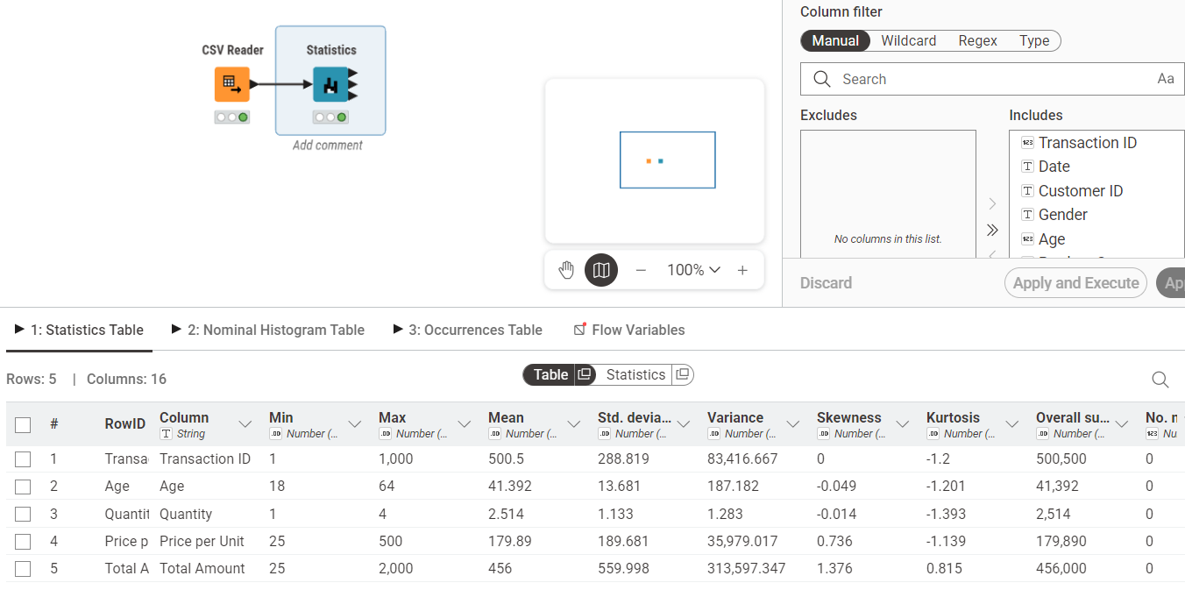

Step 6: Calculate Revenue Column
Use the Math Formula node to create a new Revenue column using the formula:
Revenue = Quantity × Price
This derived column will be used for KPI calculations.
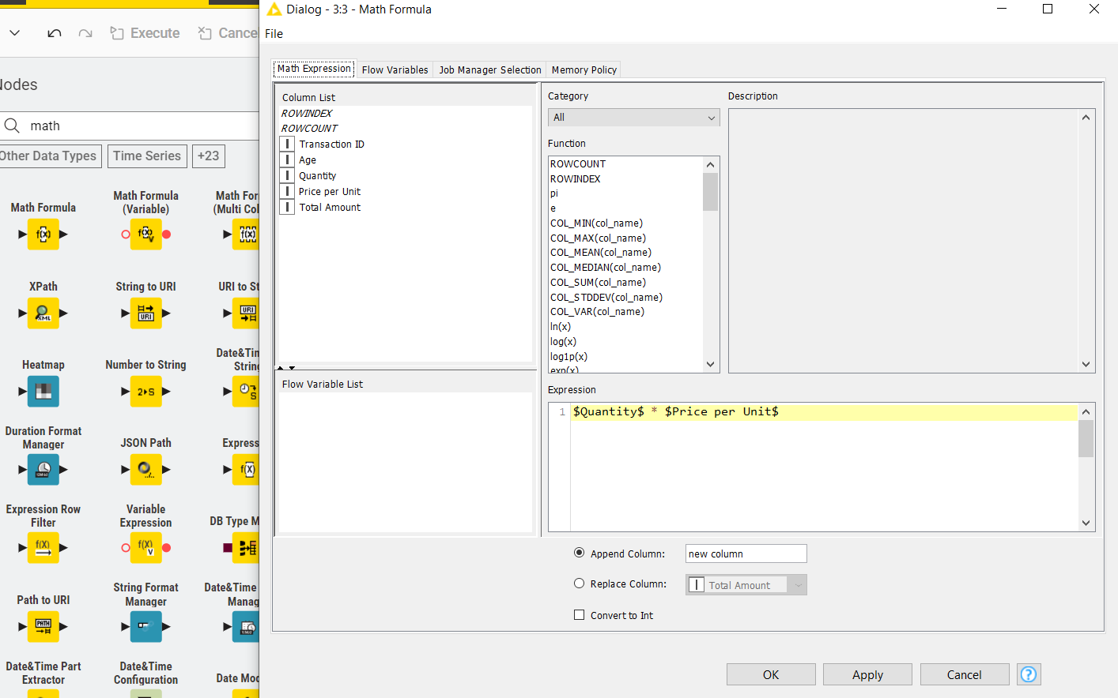
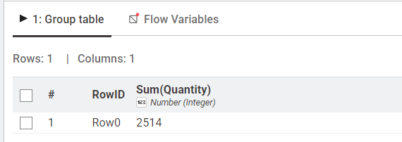

Step 7: Calculate Total Revenue (KPI 1 – Total Revenue)
Add a GroupBy node without selecting any grouping column and aggregate the Revenue column using the Sum function to compute overall sales revenue.
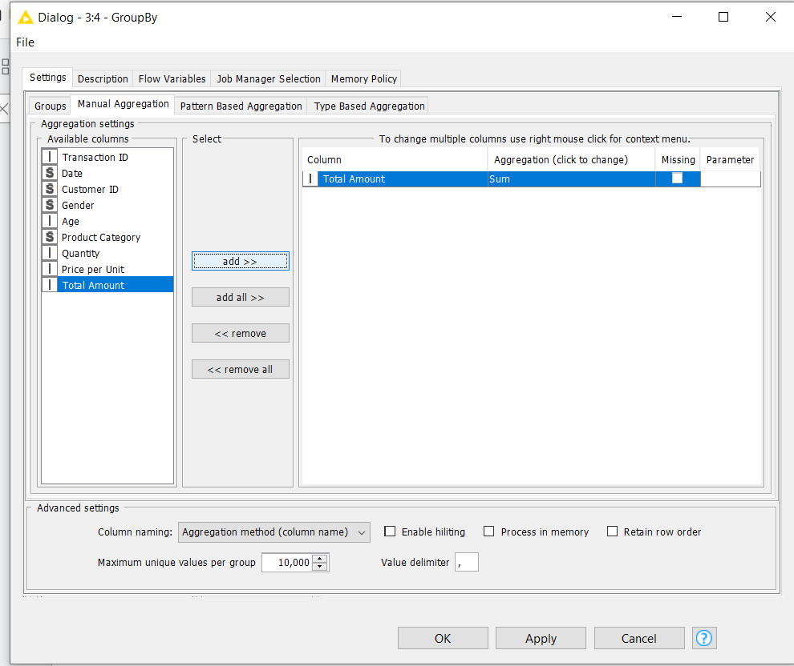

Step 8: View Total Revenue Result
Execute the node and observe the single output value representing total revenue across all transactions.
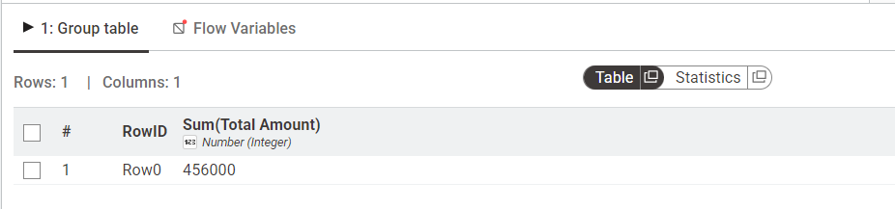

Step 9: Calculate Revenue per Transaction
Add a GroupBy node, group by Transaction ID, and aggregate Revenue using Sum to compute total revenue for each individual order.
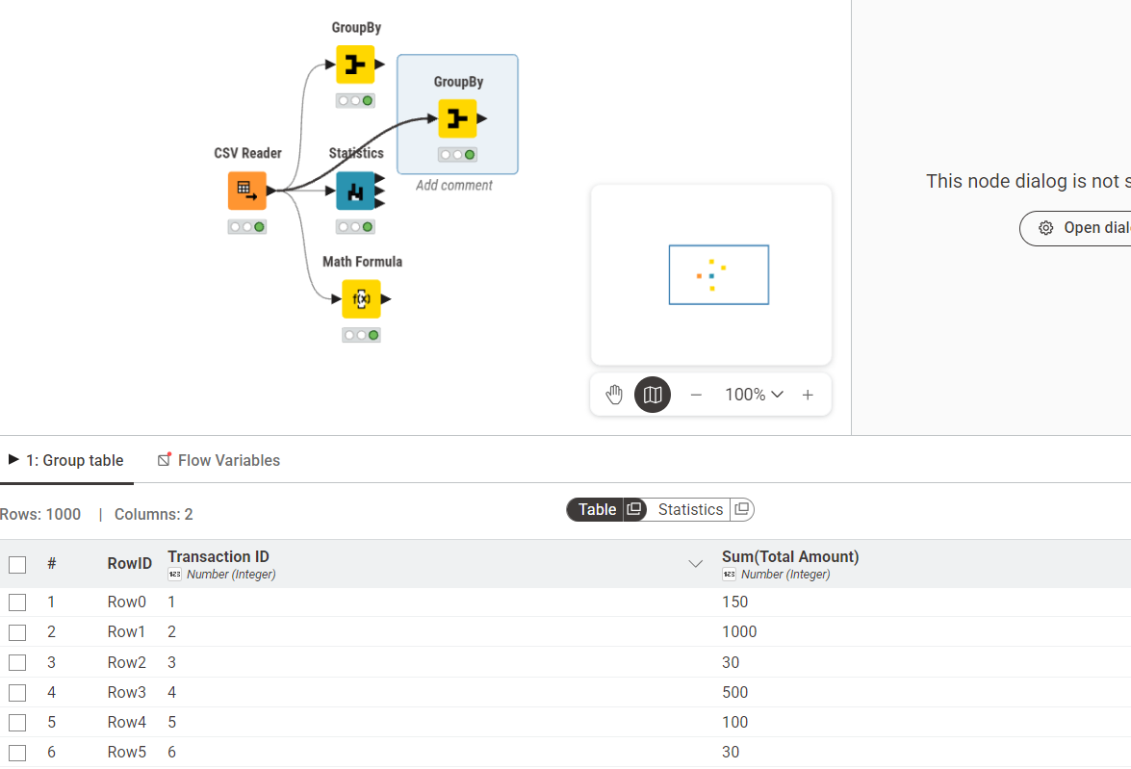

Step 10: Calculate Average of All Orders (KPI 2 – Average Order Value)
Connect a second GroupBy node with no grouping column and calculate the Mean of the aggregated revenue to determine the average order value.
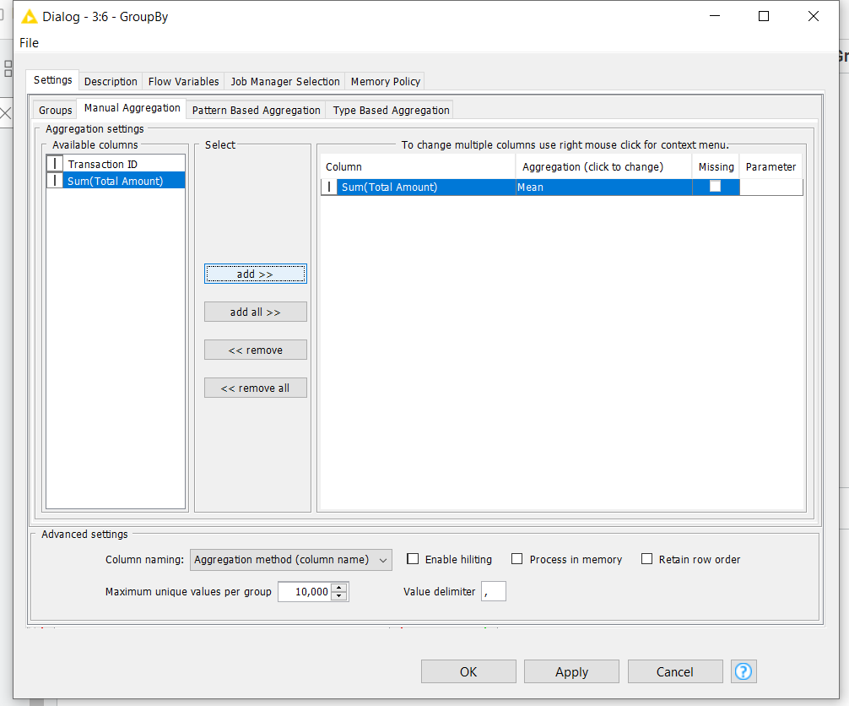

Step 11: View Average Order Value Result
Execute and review the output showing the average revenue generated per transaction.
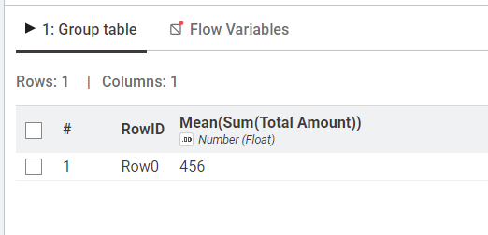

Step 12: Calculate Category Revenue (KPI 3 – Revenue by Category)
Add a GroupBy node and group by Product Category. Aggregate Revenue using Sum to compute total earnings for each category.
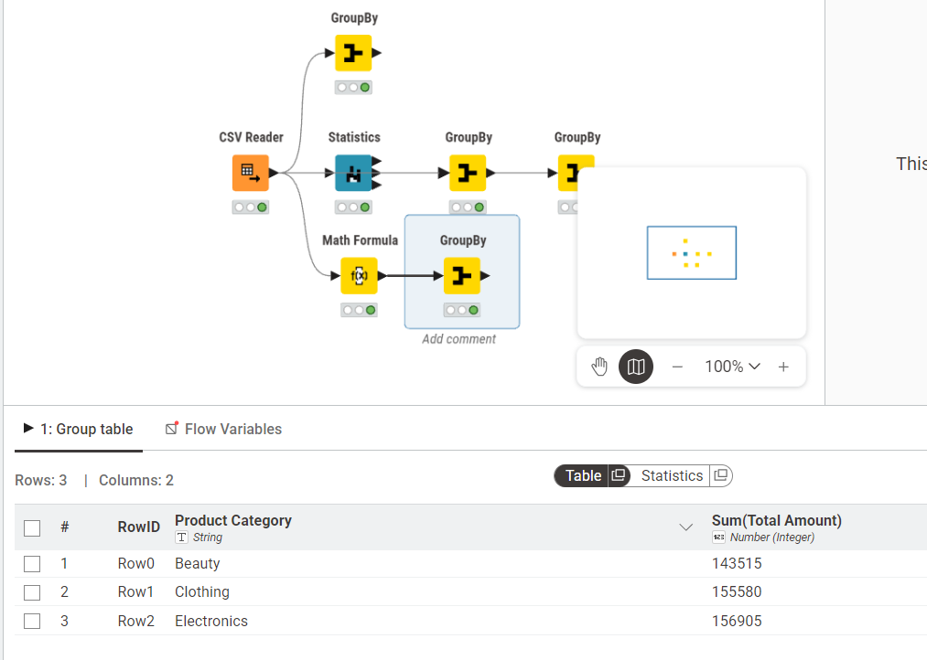

Step 13: Sort to Identify Highest Revenue Category
Connect a Sorter node and configure it to sort revenue values in descending order to rank categories from highest to lowest.
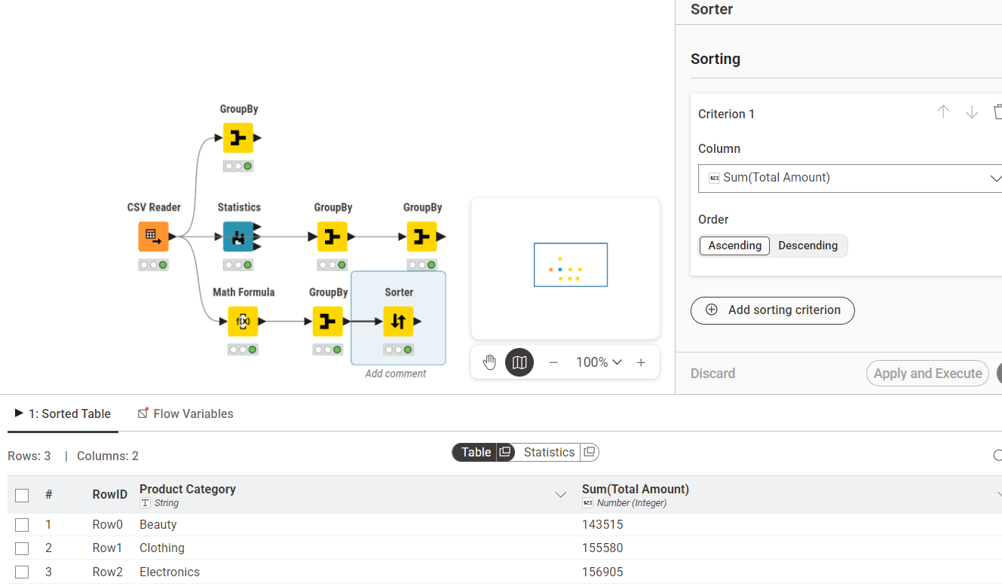

Lab 2: Customer Churn Prediction

Real-World Scenario
An e-commerce business aims to identify customers who are likely to discontinue using its services. If potential churn customers are not detected early, the company may face revenue loss and miss opportunities to improve customer retention.
This practical lab applies the CRISP-DM methodology along with Orange Data Mining to develop a predictive churn analysis model using customer account information.

Dataset Description
The dataset used in this exercise is Churn_Modelling.csv, which contains 10,000 customer records with 14 attributes.
The target column is Exited, where:
- 1 = Customer Left (Churned)
- 0 = Customer Stayed (Retained)
Important input features include:
- Credit Score
- Geography
- Gender
- Age
- Tenure
- Account Balance
- Number of Products
- Credit Card Ownership
- Active Membership Status
- Estimated Salary
During preprocessing, unnecessary columns such as RowNumber, CustomerId, and Surname were excluded.
Software Environment
Orange Data Mining
Orange is a free and open-source visual data mining tool that allows users to create machine learning workflows by connecting widgets on a canvas. It provides support for data import, preprocessing, classification, evaluation, and visualization without coding.

Practical Objectives
After completing this lab, students will be able to:
- Import and inspect a CSV dataset using File and Data Table widgets.
- Remove unnecessary columns and assign the target variable using Select Columns.
- Normalize numerical data and encode categorical features using Preprocess.
- Train Logistic Regression and Random Forest classification models.
- Compare model performance using Test and Score with 10-fold cross-validation.
- Analyze results using Confusion Matrix and ROC Analysis.
- Compute important business KPIs such as Churn Rate and Retention Rate.

Procedure
Step 1: Load the Dataset
Use the File widget to load Churn_Modelling.csv and connect it to a Data Table widget to verify all 10,000 rows and 14 columns are loaded correctly.
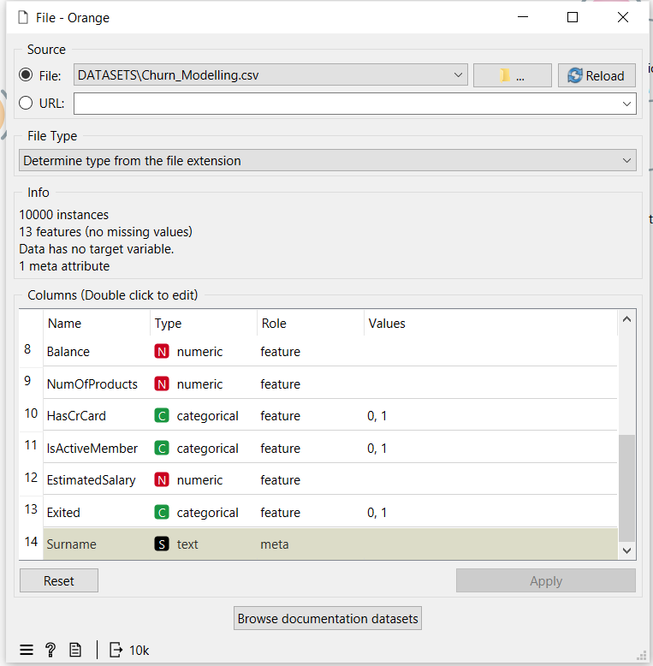
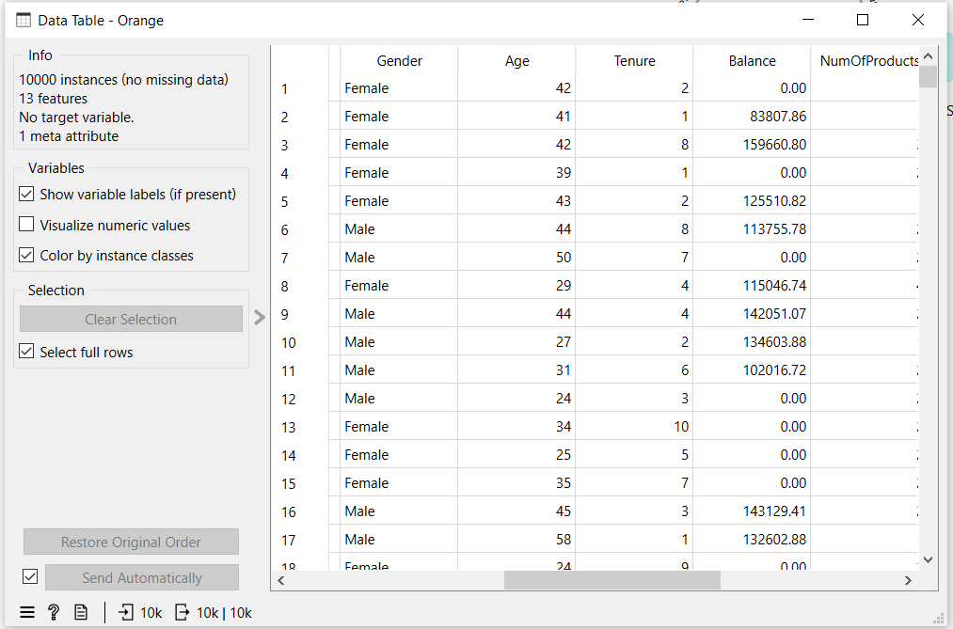

Step 2: Select Columns
Connect to a Select Columns widget. Move RowNumber, CustomerId, and Surname to the Ignore list. Set Exited as the Target class and keep all remaining features.
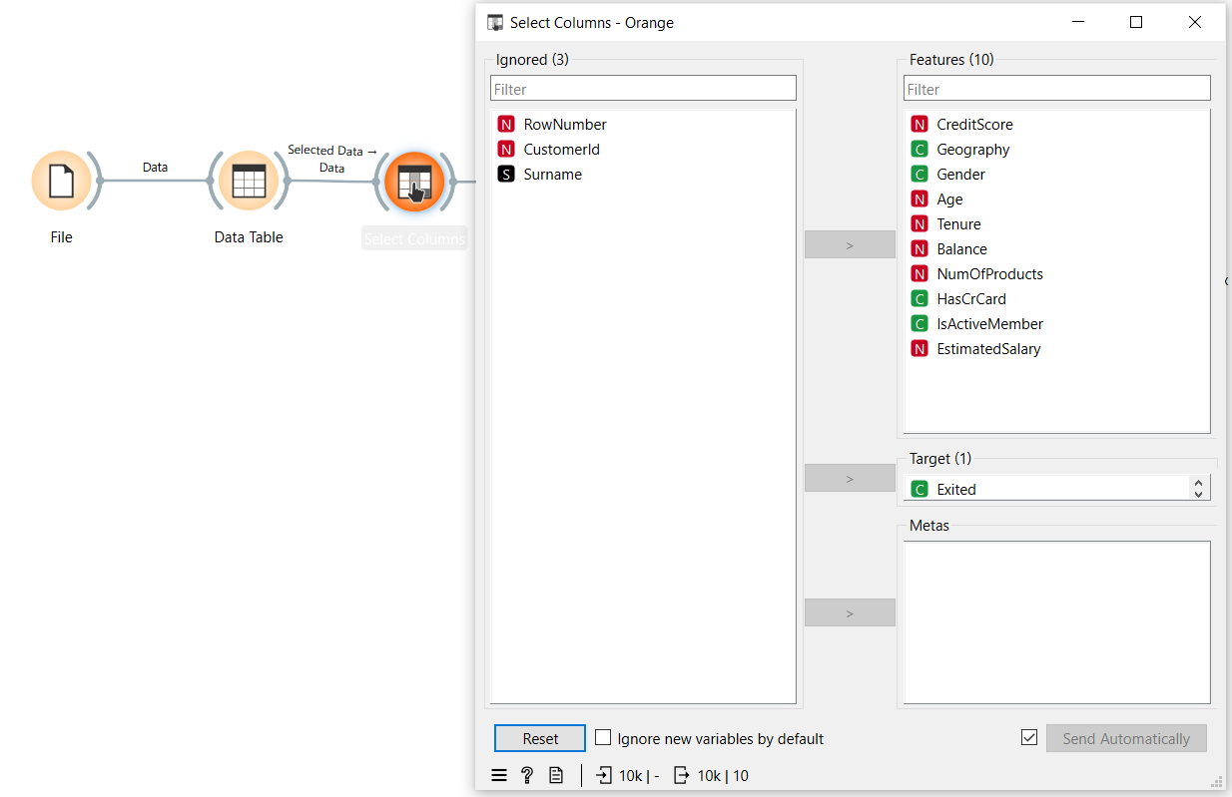

Step 3: Preprocess
Connect to a Preprocess widget and enable Min-Max normalization to scale all numeric features between 0 and 1.
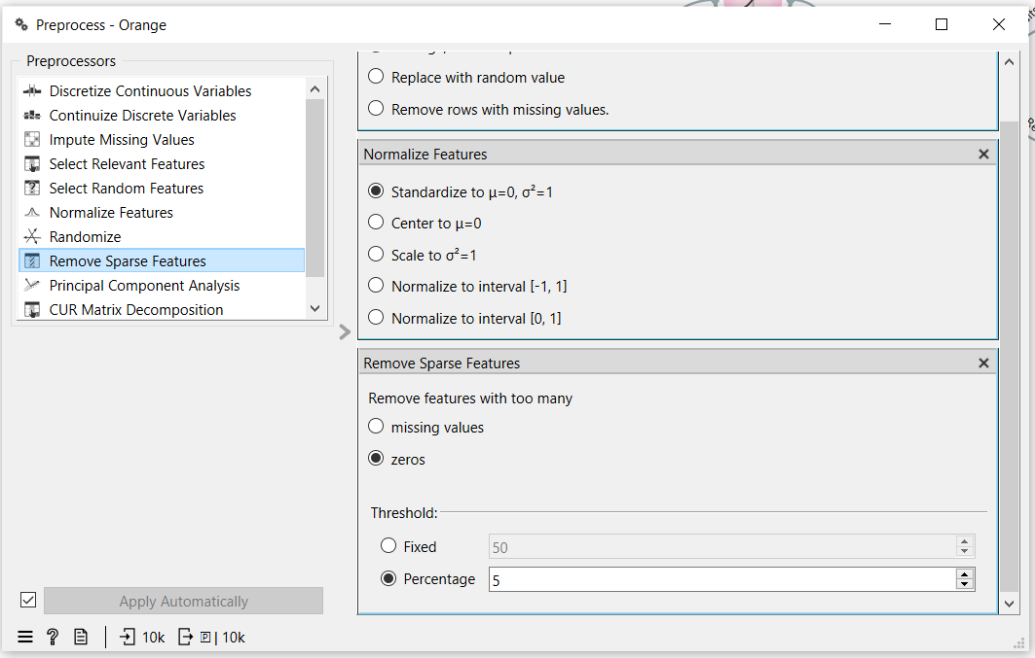

Step 4: Add Models
Connect the Preprocess widget to both a Logistic Regression widget and a Random Forest widget using the Preprocessor output port.
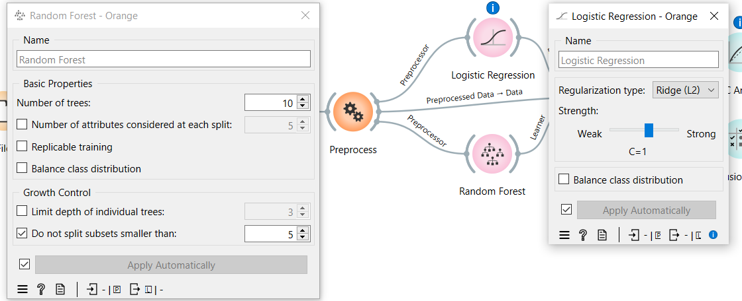
Step 5: Test and Score
Connect both learners and the preprocessed data to the Test and Score widget. Set evaluation to Cross Validation with 10 folds and enable Stratified splitting.
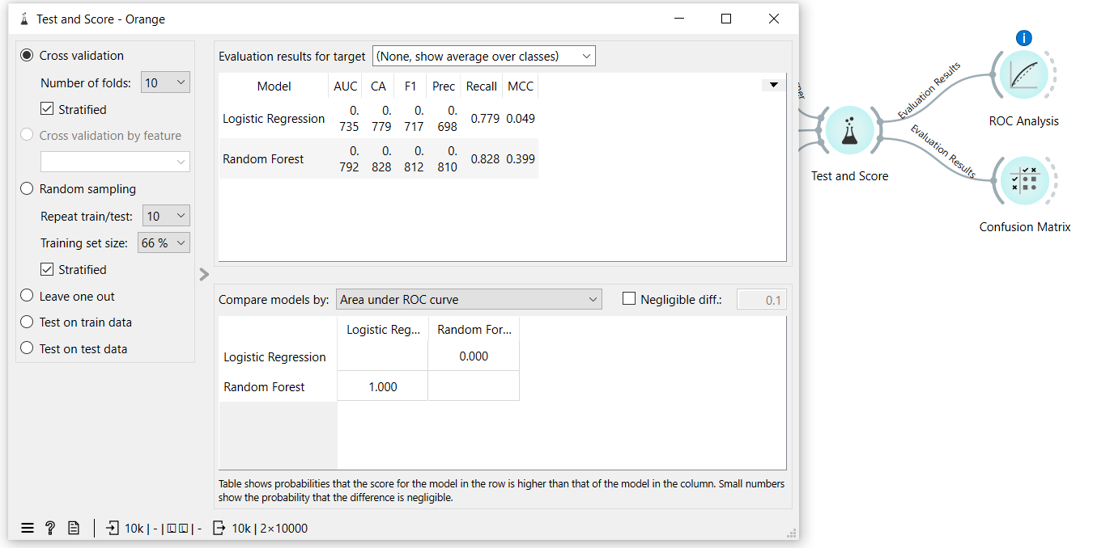

Step 6: Evaluate
Connect Test and Score to a ROC Analysis widget and a Confusion Matrix widget to visualize model performance.
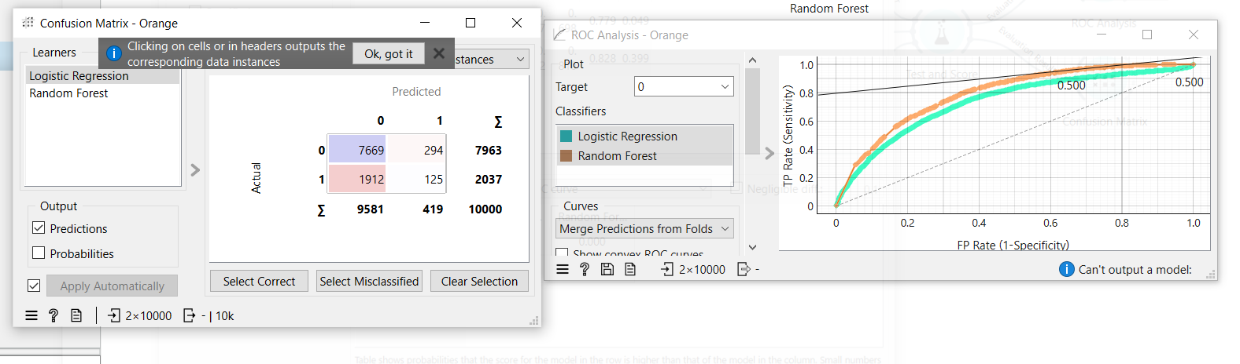

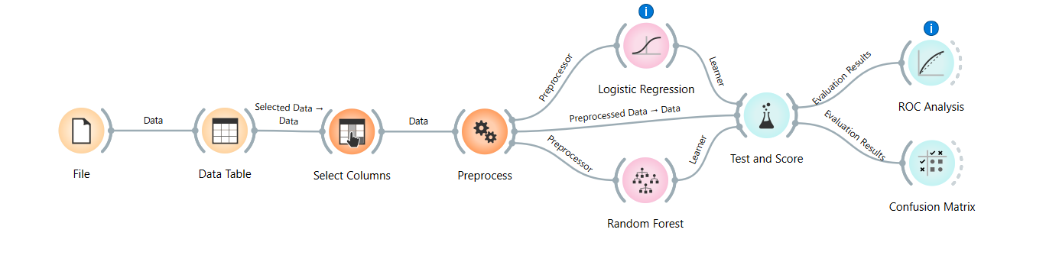
Random Forest outperformed Logistic Regression across all metrics. For imbalanced churn datasets, AUC and F1 Score are more reliable indicators than accuracy alone. The model can be deployed to score customers and trigger early retention actions for high-risk segments.

KPI | Result
Churn Rate | 20.37%
Retention Rate | 79.63%
Logistic Regression AUC | 0.735
Random Forest AUC | 0.792
Random Forest Accuracy | 82.8%
Random Forest F1 Score | 0.812

Lab 3: Data Cleaning

Real-World Scenario
Raw healthcare data often includes errors and inconsistencies such as missing information, duplicate records, and unrealistic values (for example, negative billing charges). These issues can reduce the accuracy of medical analysis and lead to weak decision-making. To make patient records reliable for healthcare analytics, an organized data cleaning process is necessary to convert raw data into a usable and analysis-ready form.

Dataset Description
The dataset used in this practical task is a Healthcare Dataset containing patient transaction-level records.
- Total Records: 55,500 rows and 15 columns
- Main Attributes: Patient Name, Age, Gender, Blood Type, Medical Condition, Billing Amount, Admission Type, Medication
Data Cleaning Focus Areas:
- Converting text into a consistent format
- Managing missing values
- Detecting and removing illogical numeric outliers
- Eliminating duplicate records

Software Environment
RapidMiner Studio / Python (Pandas & NumPy)
RapidMiner Studio and Python libraries such as Pandas and NumPy are used to perform structured data preprocessing, cleaning, and transformation tasks efficiently.

Practical Objectives
After completing this lab, students will be able to:
- Detect and handle missing values in healthcare records.
- Remove duplicate rows to improve data consistency.
- Reduce data noise by standardizing text values and filtering invalid numerical entries.
- Prepare a clean dataset suitable for healthcare analytics.
- Calculate important KPIs such as:
  - Percentage of Missing Values Reduced
  - Duplicate Removal Percentage
  - Data Quality Score

Procedure & Steps
Step 1: Environment Setup & Data Loading
Initialize the environment by importing necessary libraries (Pandas, NumPy) and loading the healthcare dataset for inspection.
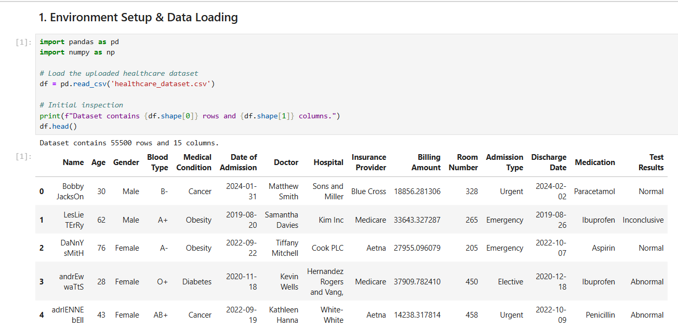

Step 2: Initial Data Inspection
Check the dataset dimensions and identify initial issues like missing values across different columns.
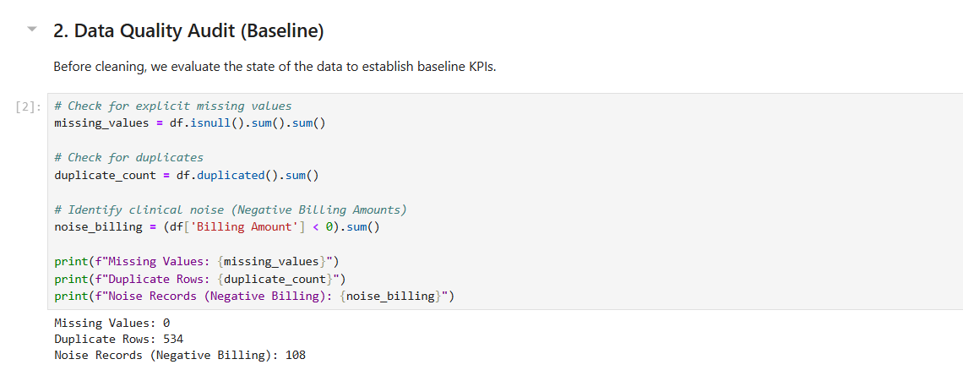

Step 3: Duplicate Record Removal
Scan the dataset for identical patient entries and remove redundant rows to ensure each record is unique.
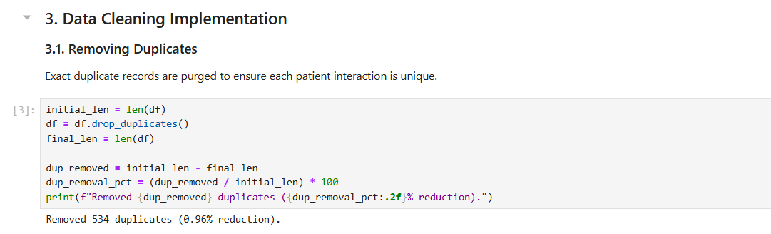

Step 4: Clinical Noise Filtering & Standardizing
Standardize text casing (e.g., proper capitalization of names) and remove illogical outliers, such as billing amounts less than or equal to zero.
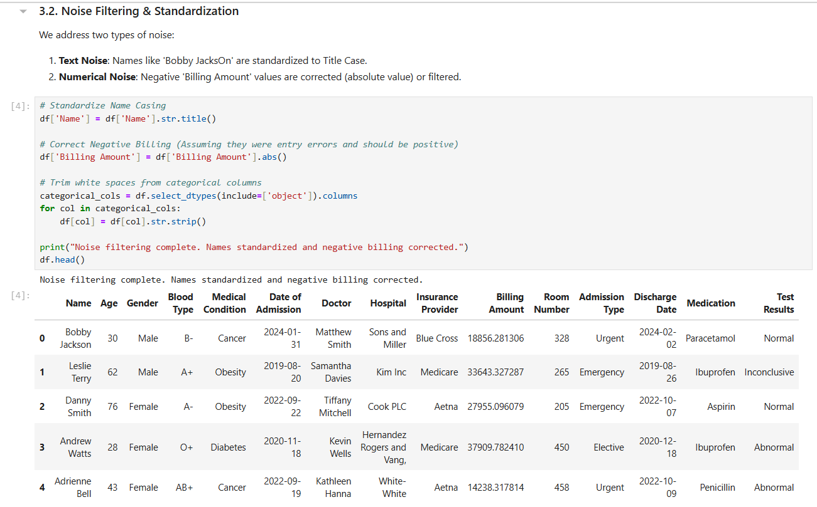

Step 5: KPI Calculation
Compute performance metrics to verify the quality of the cleane
d data, including the final Data Quality Score.
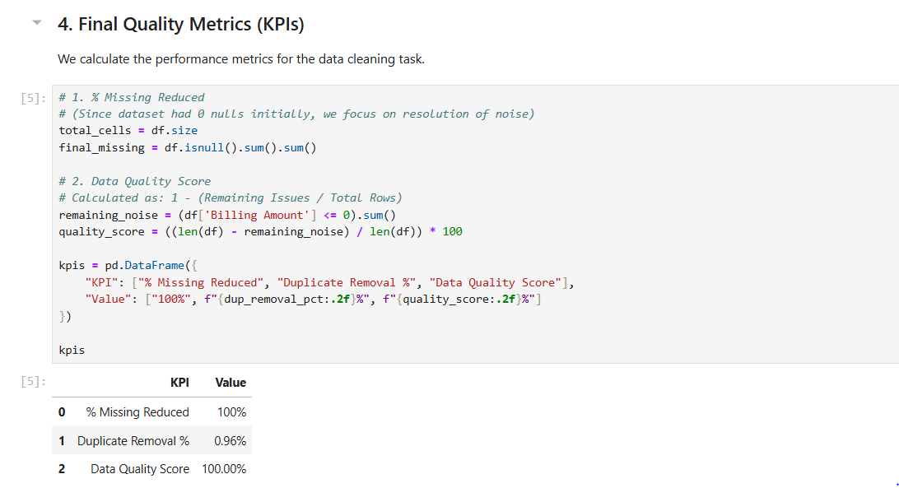
Step 6: Export Cleaned Data
Save the final processed dataset as a new file (e.g., cleaned_healthcare_data.csv) for future analysis. 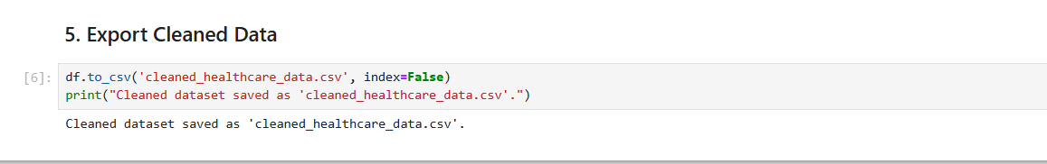

Lab 4: Data Preprocessing

Real-World Scenario
A banking institution must evaluate the risk level of loan applicants before granting loan approvals. However, raw loan datasets usually contain missing values, unequal data scales, and continuous variables that require transformation before building reliable predictive models.
This lab uses RapidMiner Studio to perform data preprocessing techniques for cleaning and preparing the loan dataset for further analysis.

Dataset Description
The dataset used in this exercise is loan_dataset_20000.csv, containing 20,000 loan application records.
Important attributes include:
- Age
- Annual Income
- Monthly Income
- Debt-to-Income Ratio
- Credit Score
- Loan Amount
- Interest Rate
- Loan Term
- Installment Amount
After handling missing values, 8,231 clean and valid records remained for processing.

Software Environment
RapidMiner Studio
RapidMiner is a visual data science and analytics platform that enables users to design workflows by connecting operators. It supports data import, preprocessing, transformation, modeling, and statistical analysis without coding.
Practical Objectives
After completing this lab, students will be able to:
- Import a CSV dataset using the Retrieve operator.
- Handle incomplete records using Replace Missing Values.
- Normalize numerical features through Z-Score Normalization.
- Apply Z-Score Peak Transformation to reduce outlier effects.
- Convert continuous variables into categories using Discretization.
- Generate descriptive summaries using the Statistics operator.
- Measure preprocessing success through KPIs such as:
  - Variance Reduction
  - Distribution Improvement

Procedure
Step 1: Load the Dataset
Use the Retrieve operator to load loan_dataset_20000.csv into the workflow. Connect it to the next operator to begin preprocessing.
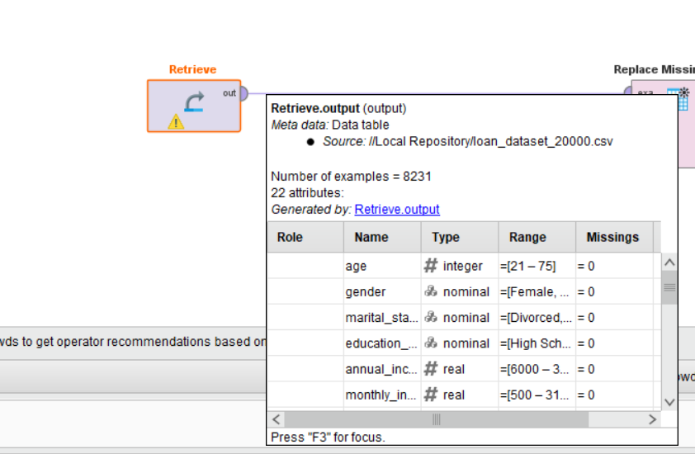

Step 2: Replace Missing Values
Connect to a Replace Missing Values operator. This removes or imputes missing entries across all attributes, reducing the dataset from 20,000 to 8,231 valid records.
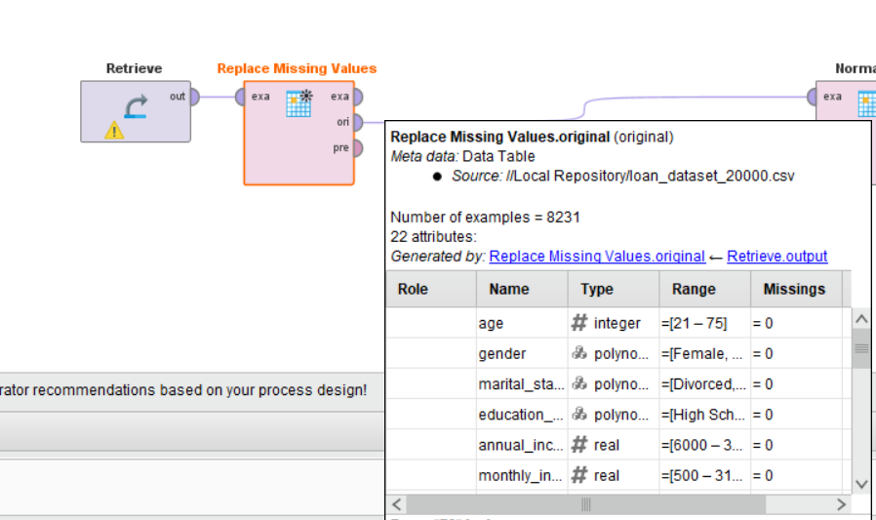

Step 3: Normalize
Connect to a Normalize operator and apply Z-Score normalization. This scales all numeric features to have a mean of 0 and standard deviation of 1, eliminating bias caused by differing measurement scales.
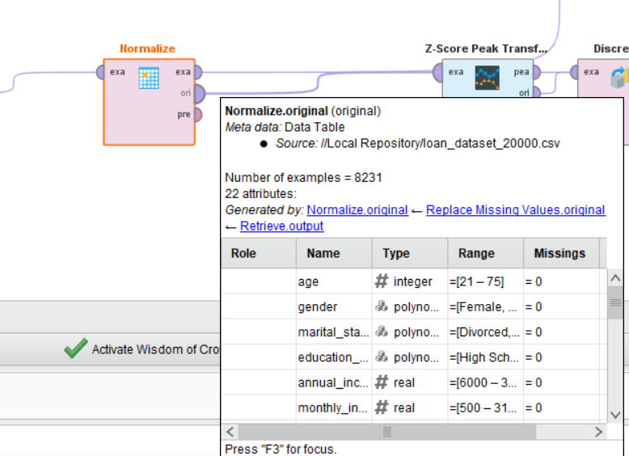
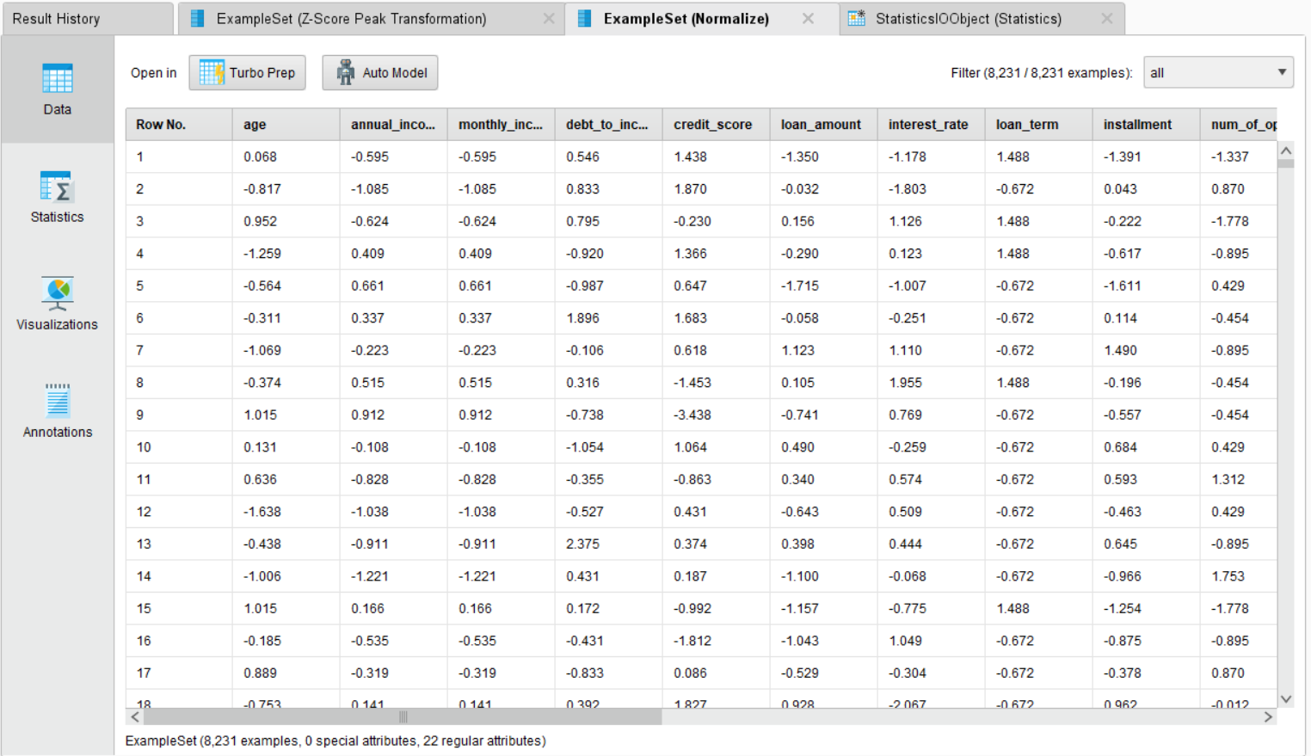

Step 4: Z-Score Peak Transformation
Connect to a Z-Score Peak Transformation operator. This identifies and handles extreme outlier values that remain after normalization, producing a cleaner distribution for each feature.
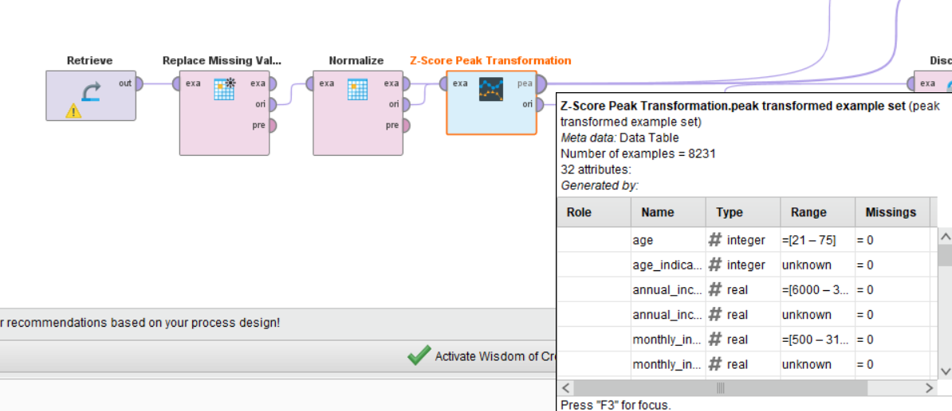
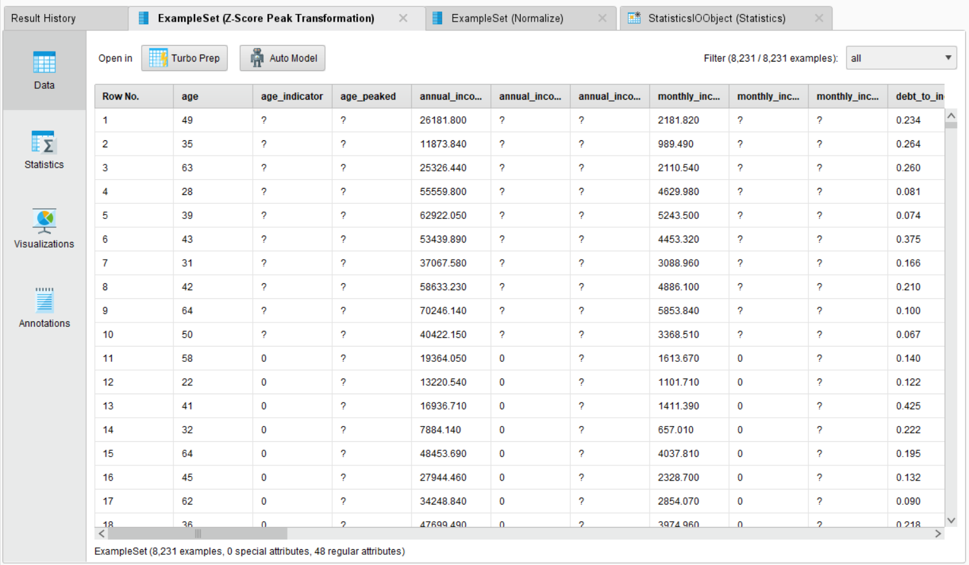

Step 5: Discretize
Connect to a Discretize operator. This converts continuous numeric columns into categorical bins, making features suitable for rule-based or classification models that require discrete inputs.
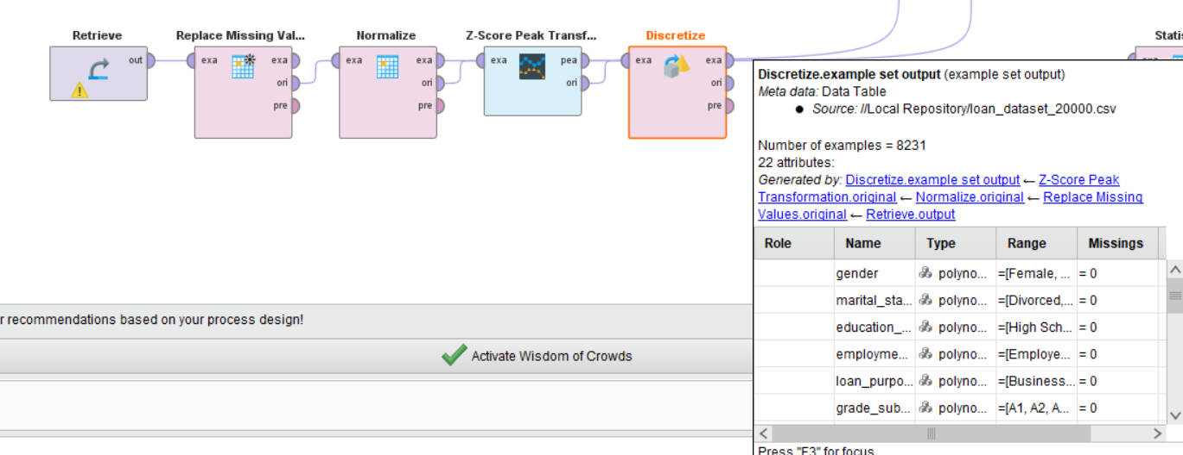

Step 6: Generate Statistics
Connect all result outputs to a Statistics operator. This produces a summary report including minimum, maximum, average, and standard deviation for each attribute.
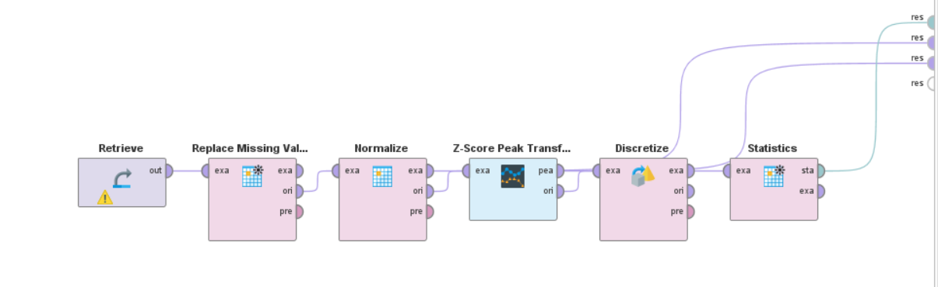
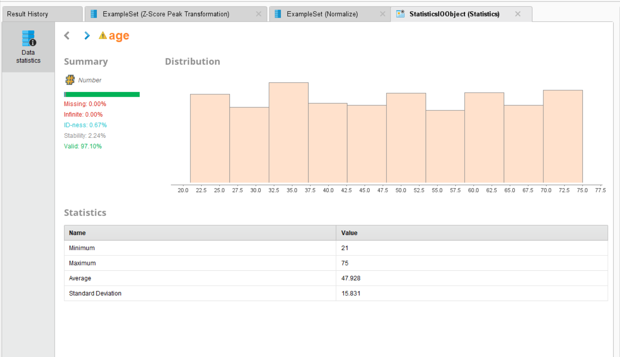

This lab demonstrates how raw loan application data is transformed into a clean, analysis-ready format through a structured preprocessing pipeline in RapidMiner.
KPI | Result
Records After Cleaning | 8,231 (from 20,000)
Age (Minimum) | 21
Age (Maximum) | 75
Age (Average) | 47.928
Age (Standard Deviation) | 15.831
Missing Values After Processing | 0.00%
Valid Data Rate | 97.10%

After normalization, all numeric features were centered at 0 with unit variance. Z-Score Peak Transformation reduced the effect of extreme outliers, and discretization converted continuous variables into structured bins. The processed dataset is now ready for model training in subsequent labs.

Lab 5: Market Basket Analysis

Real-World Scenario
Supermarkets process a large number of customer purchases every day. Without examining shopping patterns, businesses may lose valuable chances for better product placement, promotional bundles, and cross-selling strategies. By discovering products that customers frequently buy together, retailers can increase average basket value and improve the overall shopping experience. For example, commonly paired items can be placed close to each other to encourage additional purchases.

Dataset Description
The analysis is performed using the Groceries Dataset, which contains member-based shopping transaction records.
Main Attributes:
- Member_number
- Date
- ItemDescription
Dataset Structure:
- Each row represents one purchased item.
- Multiple items bought by the same member on the same date are combined to form one transaction.
- The dataset contains approximately 14,963 unique transactions.

Software Environment
Python
Python is used for this practical task, mainly with:
- Pandas for data cleaning, grouping, and transaction preparation
- Manual calculations for validating association rule metrics
This environment helps perform market basket analysis efficiently.
Practical Objectives
After completing this lab, students will be able to:
- Identify frequent itemsets that appear regularly in customer baskets.
- Perform association rule mining using key measures such as:
  - Support
  - Confidence
  - Lift
- Compare manual metric calculations with program-generated results for accuracy.
- Evaluate business opportunities using KPIs such as:
  - High Lift (>1)
  - Strong Confidence Values
  - Cross-Selling Potential

Procedure & Steps
Step 1: Data Preparation & Transaction Grouping
Group the raw CSV data by Member_number and Date to define unique transactions. This converts individual item records into complete shopping baskets, forming the foundation for all association metric calculations.
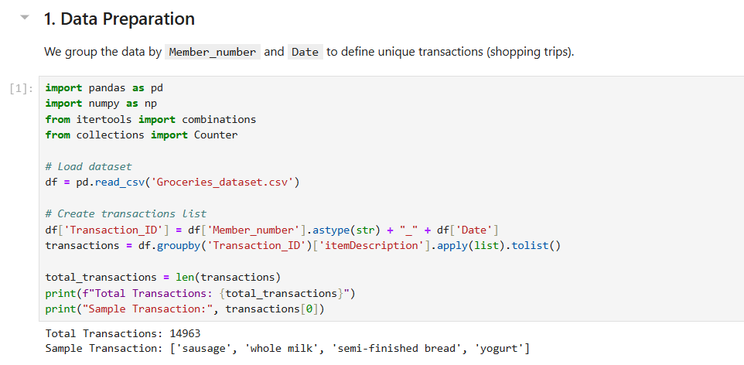

Step 2: Manual Calculation of Support, Confidence & Lift
Manually calculate Support, Confidence, and Lift for a specific item pair to validate the logic. Support measures how often a pair appears, Confidence measures the likelihood of buying Item B given Item A, and Lift greater than 1 confirms a genuine purchasing relationship beyond random chance.
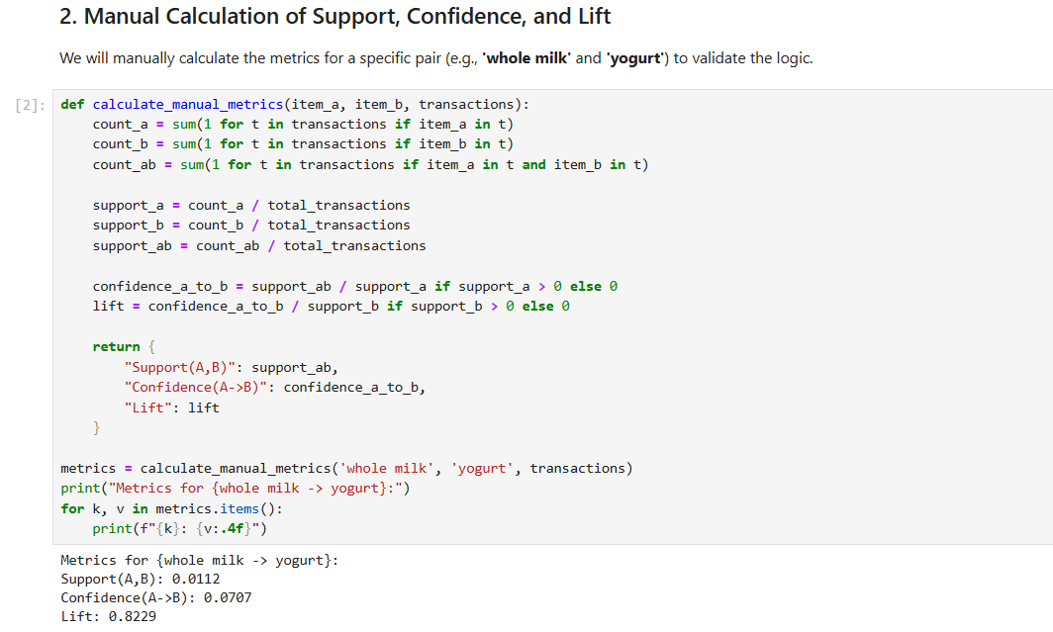

Step 3: Frequent Itemsets & Rule Generation
Compute metrics for every possible item pair across all transactions to generate a complete set of association rules. Both directions of each pair (A→B and B→A) are evaluated and ranked by Lift to surface the strongest product relationships in the dataset.
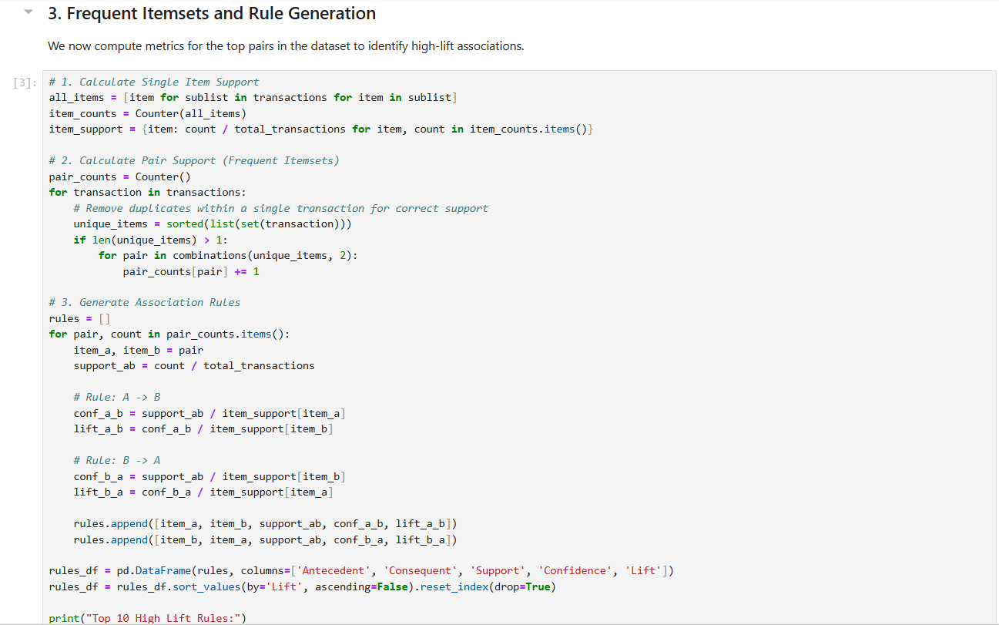
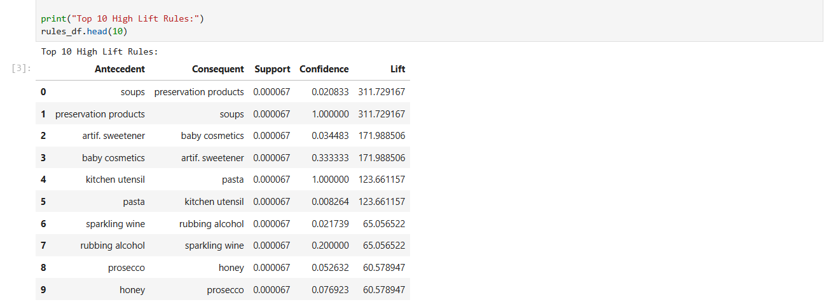
Step 4: Filtering Significant Rules
Filter the results to isolate "Significant Rules"—those with Lift greater than 1 and Confidence above 0.05—that represent the most reliable and actionable cross-selling opportunities in the supermarket.
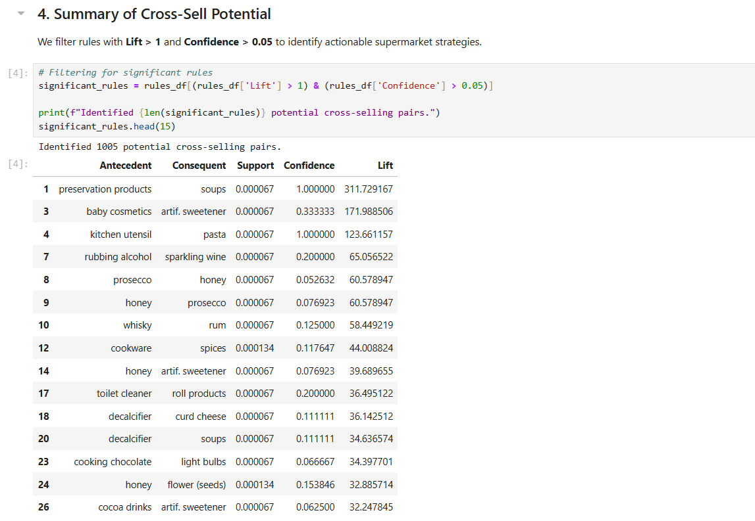

Step 5: Strategic Conclusion
Summarize the findings to provide actionable business advice, identifying high-lift item pairs as prime candidates for shelf co-location, promotional bundling, and targeted cross-selling strategies to increase average transaction value.
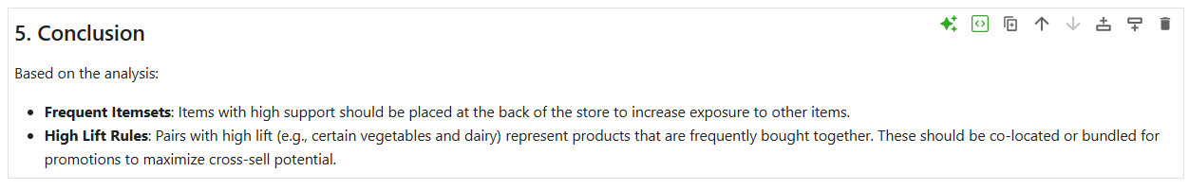

Lab 6: Apriori Algorithm (Product Combination Analysis)

Real-World Scenario
Retail businesses process a high volume of customer purchases every day. However, without proper analytical methods, hidden buying relationships between product categories remain unnoticed. By using the Apriori algorithm, companies can identify categories that customers frequently purchase together. These insights help businesses create targeted promotions, product bundles, and marketing strategies that improve customer retention and overall sales value.

Dataset Description
The analysis is performed using a Retail Transaction Dataset containing customer purchase records from multiple product categories.
Main Attributes:
- CustomerID
- ProductCategory
- Quantity
Dataset Structure:
- Each row represents one purchased product.
- Records are grouped by CustomerID to create a unique customer basket.
- The transaction matrix includes 95,215 customers across 4 product categories:
  - Books
  - Clothing
  - Electronics
  - Home Decor

Software Environment
Python
Python is used to process and analyze the dataset with the following tools:
- Pandas for data cleaning, reshaping, and basket matrix creation
- mlxtend Library for applying:
  - apriori() function
  - association_rules() function
These tools support efficient market basket analysis and rule generation.

Practical Objectives
After completing this lab, students will be able to:
- Convert raw purchase data into a binary customer-item basket matrix.
- Discover frequent itemsets that regularly appear together in customer purchase histories.
- Generate association rules and evaluate them using:
  - Support
  - Confidence
  - Lift
- Analyze KPIs by observing how changes in minimum support values affect the number of generated rules.

Procedure & Steps
Step 1: Environment Setup & Data Preparation
Install mlxtend and load the dataset. Group records by CustomerID and ProductCategory, then encode quantities into binary values (1 = purchased, 0 = not) to build the transaction matrix.
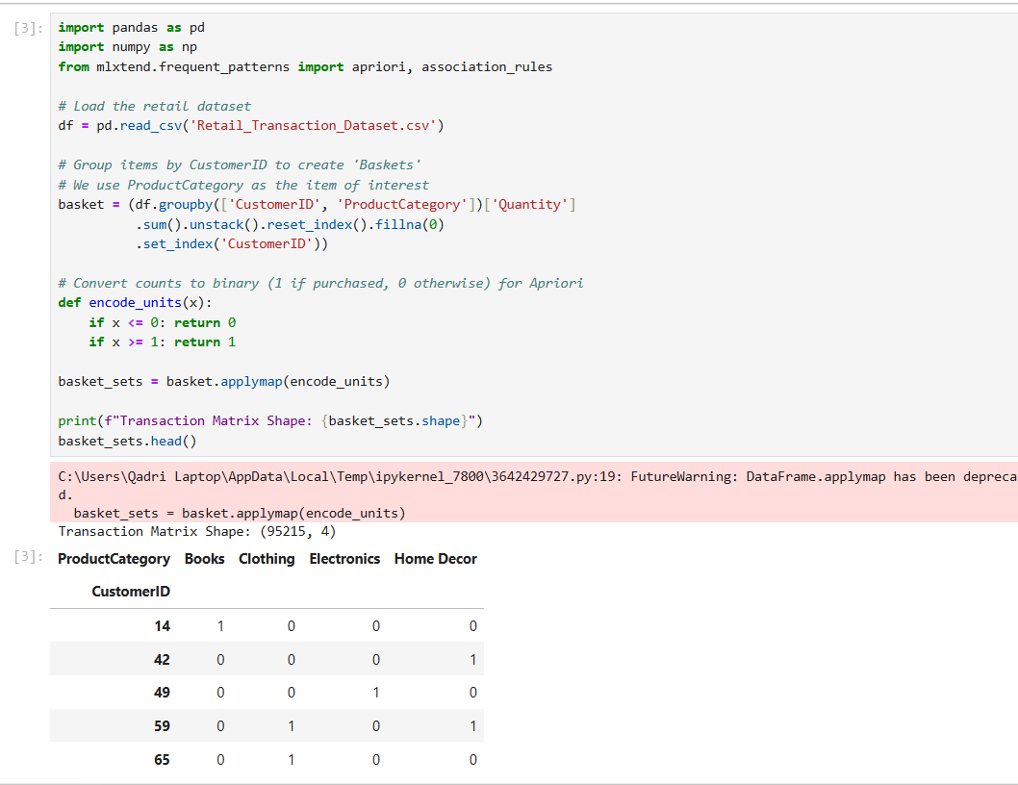

Step 2: Frequent Itemset Generation
Apply the Apriori algorithm with a minimum support of 0.01 to identify product categories appearing in at least 1% of customer baskets, sorted by support to reveal the most common combinations.
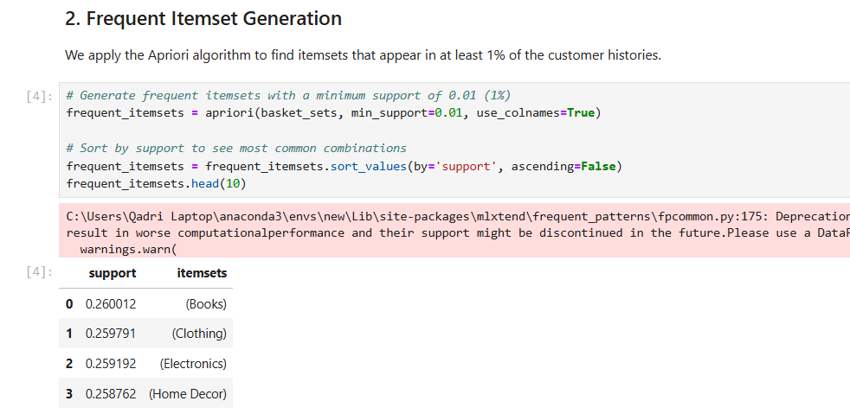

Step 3: Rule Generation & Association Discovery
Generate association rules from the frequent itemsets using Lift as the primary metric. Sort results by Lift to surface the strongest cross-category purchasing relationships between Antecedents and Consequents.
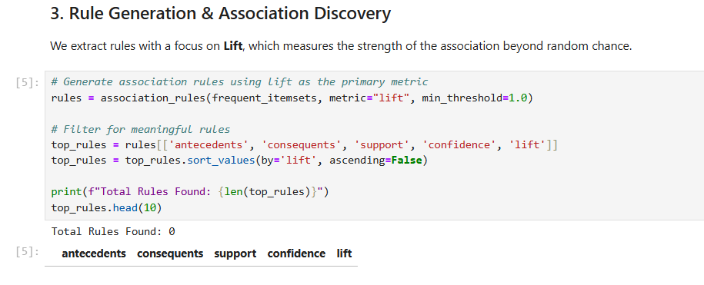

Step 4: KPI Analysis (Support Threshold Impact)
Test four support thresholds (0.005, 0.01, 0.02, 0.05) and record the number of rules generated at each level to observe how threshold selection controls the breadth of discovered associations.
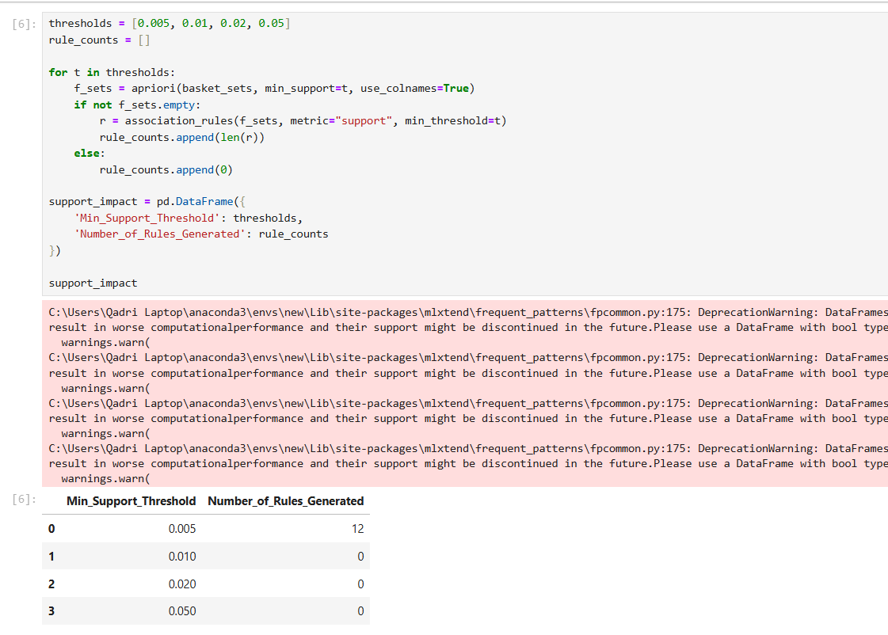
Step 5: Strategic Conclusion
Summarize findings to identify dominant product combinations, high-lift cross-sell pairs for bundled promotions, and the effect of support thresholds on rule discovery for informed retail decision-making.
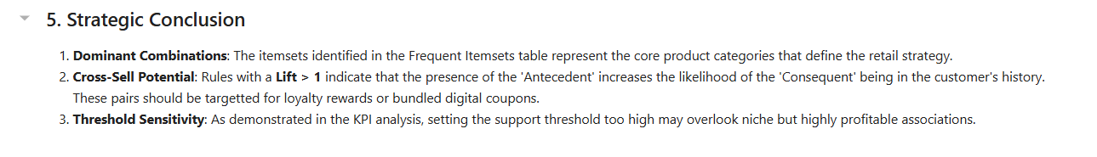

Lab 7: FP-Growth (Efficient Frequent Pattern Mining)

Real-World Scenario
As retail transaction data increases in size, traditional market basket algorithms such as Apriori become slower because they require repeated database scanning and large candidate set generation. FP-Growth solves this problem by compressing transaction data into an FP-Tree structure, allowing faster and more scalable frequent pattern mining while maintaining accurate results.

Dataset Description
The analysis is performed using the New Retail Dataset, which contains customer purchase records across multiple product types.
Main Attributes:
- Transaction_ID
- Product_Type
- Total_Purchases
Dataset Structure:
- Each row represents one purchased product.
- Records are grouped by Transaction_ID to create unique customer baskets.
- The transaction matrix contains 294,461 transactions across 33 unique product types.

Software Environment
Python
Python is used for preprocessing and analysis with the following tools:
- Pandas for data transformation and one-hot encoding
- mlxtend Library for applying:
  - apriori()
  - fpgrowth()
Practical Objectives
After completing this lab, students will be able to:
- Construct an FP-Tree from the transaction matrix for efficient frequent pattern discovery.
- Compare the execution performance of FP-Growth and Apriori using the same support threshold.
- Generate association rules from FP-Growth results using Lift as the main evaluation metric.
- Analyze KPIs such as:
  - Execution Time
  - Number of Rules Generated
  - Efficiency Improvement over Apriori

Procedure & Steps
Step 1: Environment Setup
Install the mlxtend library and import pandas, time, apriori, fpgrowth, and association_rules to prepare the environment for both algorithms.
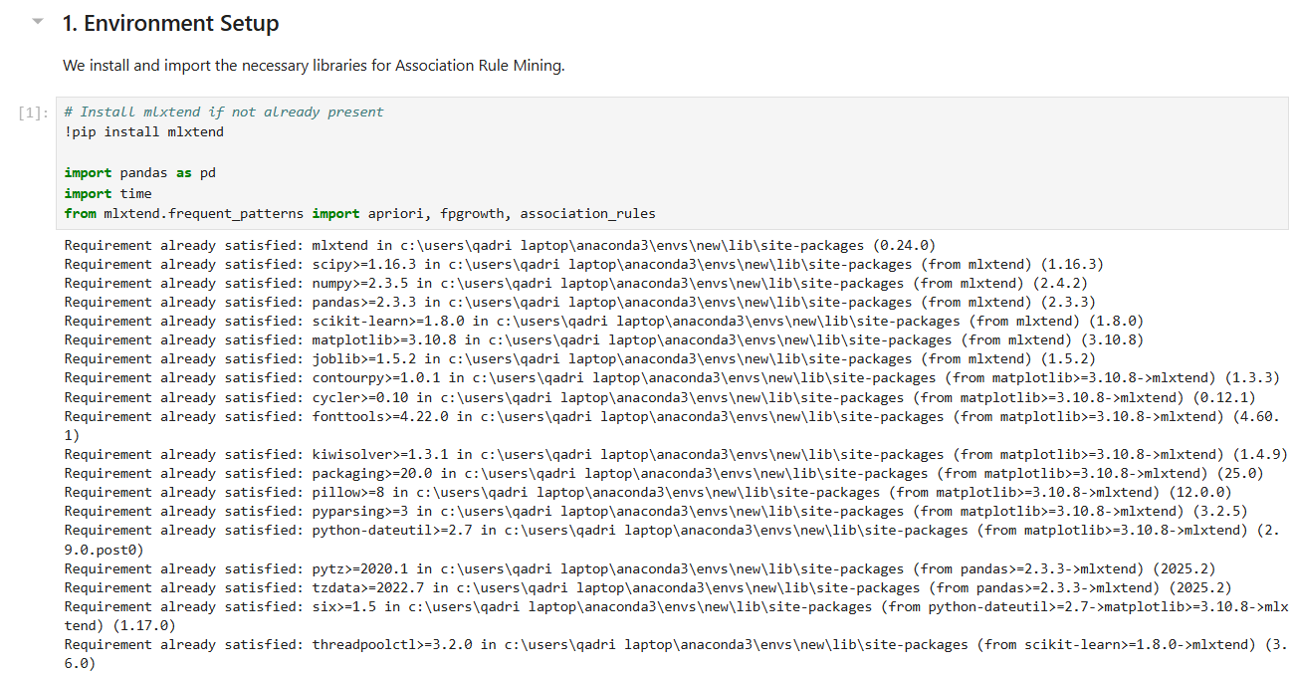

Step 2: Data Preprocessing
Load the dataset and drop missing values in Transaction_ID and Product_Type. Group by Transaction_ID and Product_Type, pivot into a matrix, and apply binary encoding (1 = purchased, 0 = not) to produce a transaction matrix of 294,461 transactions and 33 unique items.
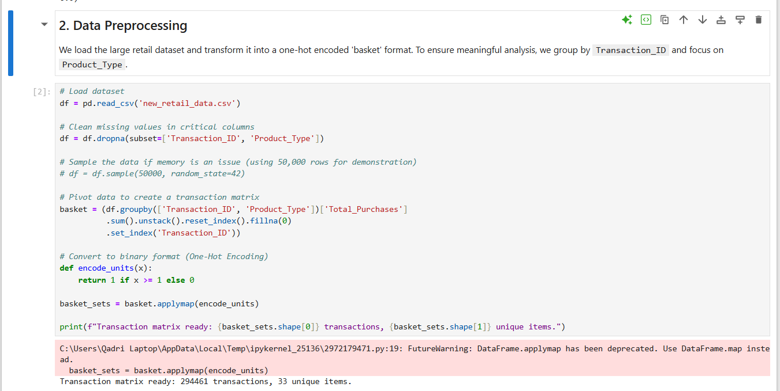

Step 3: Apriori Execution
Run the Apriori algorithm with a minimum support of 0.005 and record its execution time using Python's time module. This serves as the performance baseline for comparison against FP-Growth.
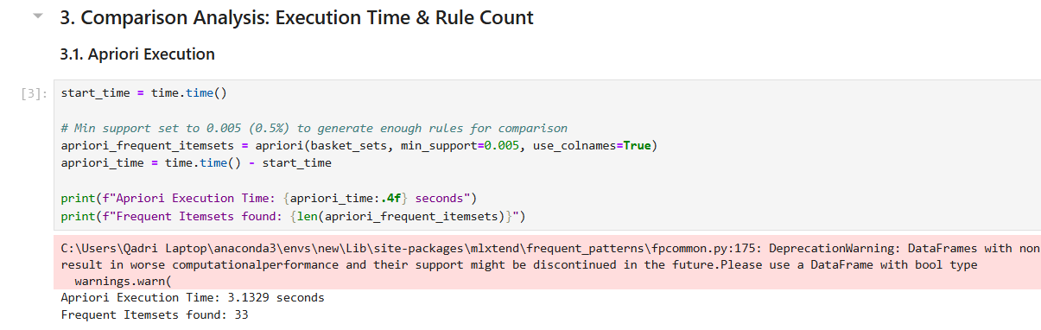

Step 4: FP-Growth Execution
Run the FP-Growth algorithm on the same transaction matrix with the same minimum support of 0.005. Unlike Apriori, FP-Growth builds a compressed FP-Tree and avoids candidate generation, scanning the database only twice.
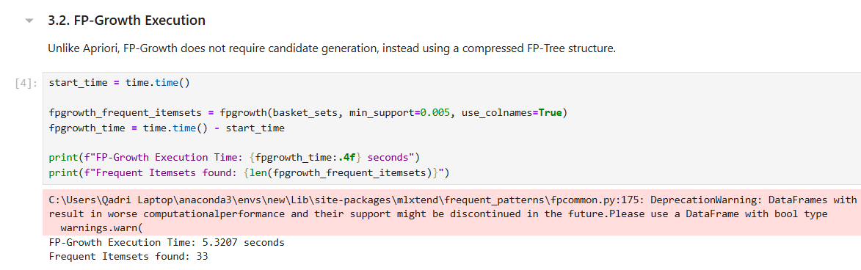

Step 5: Rule Generation & KPI Summary
Generate association rules from the FP-Growth frequent itemsets using Lift as the metric. Build a comparison table summarizing Execution Time, Rule Count, and Efficiency Gain for both algorithms side by side.
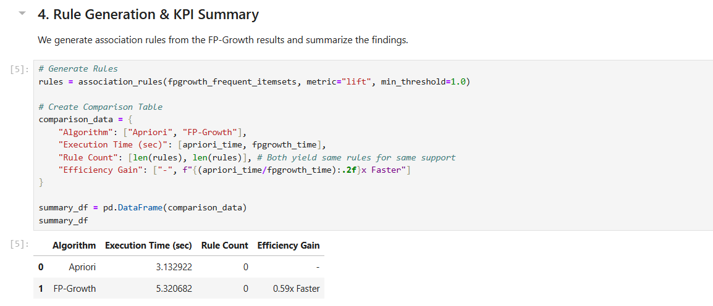

Step 6: Final Insights
Summarize that both algorithms produce identical rule counts at the same support threshold, confirming that FP-Growth's speed advantage does not compromise accuracy — making it the preferred choice for large-scale retail datasets.
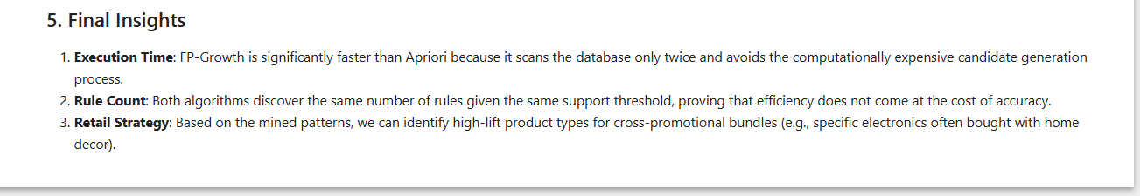

Lab 8: Python Basics (Reusable Data Processing Module)

Real-World Scenario
Data analysts often repeat the same preprocessing steps such as loading data, cleaning records, encoding categorical values, and normalizing numeric features for different datasets. Without a structured solution, this can create repetitive code, wasted time, and inconsistent outputs. By developing a reusable Python class, all preprocessing tasks can be organized in one system, making data pipelines faster, easier to manage, and suitable for multiple structured datasets.

Dataset Description
The analysis is carried out using the Student Performance Dataset, which contains academic and demographic information of students.
Main Attributes:
- student_id
- gender
- school_type
- attendance_percentage
- study_hours
- math_score
- science_score
- english_score
- overall_score
- final_grade
Dataset Structure:
- Each row represents the complete academic profile of one student.
- The dataset contains 25,000 student records.
Software Environment
Python
Python is used for data preprocessing and analysis with:
- Pandas for data handling and transformation
- NumPy for numerical calculations and array operations
Object-Oriented Programming (OOP)
A StudentDataProcessor class is designed to combine all preprocessing operations into a reusable and organized structure.

Practical Objectives
After completing this lab, students will be able to:
- Design a reusable Python class for loading, cleaning, and preprocessing data.
- Apply label encoding to categorical columns.
- Use Min-Max Normalization for score-related numerical columns.
- Store metadata and summary results using lists and dictionary structures.
- Evaluate KPIs such as:
  - Code Efficiency
  - Reusability
  - Better Workflow Management

Procedure & Steps
Step 1: Module Definition
Define the StudentDataProcessor class with an __init__ method that accepts a file path and initializes the DataFrame and a statistics dictionary. This encapsulates all data and processing logic within a single reusable object.
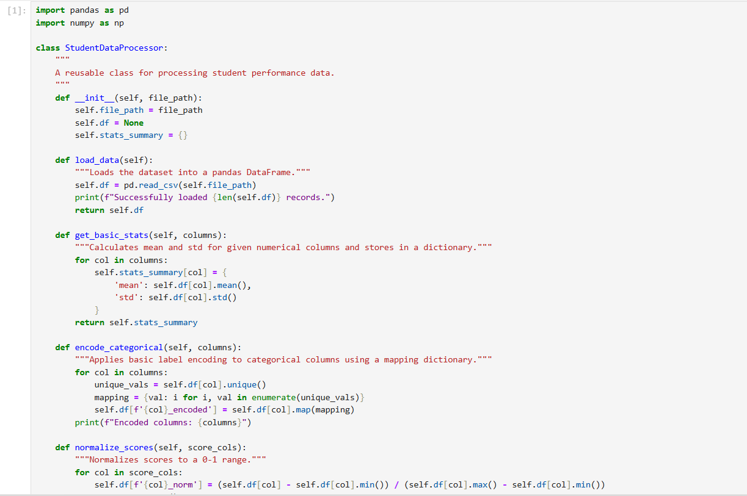

Step 2: Data Loading & Basic Statistics
Instantiate the class with Student_Performance.csv and call load_data() to read 25,000 records. Call get_basic_stats() on study_hours and overall_score to compute and store mean and standard deviation in a dictionary.
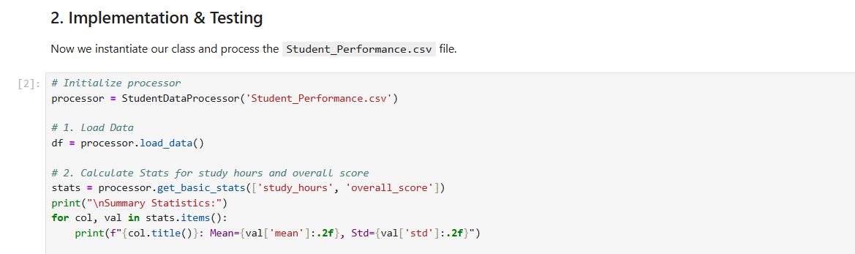
Step 3: Categorical Encoding
Call encode_categorical() on the gender, school_type, and final_grade columns. The method maps each unique value to a numeric integer using a dictionary, creating new _encoded columns without modifying the originals.
Step 4: Score Normalization
Call normalize_scores() on math_score, science_score, and english_score. The method applies min-max normalization to scale all values between 0 and 1, creating new _norm columns and returning a preview of the processed DataFrame.
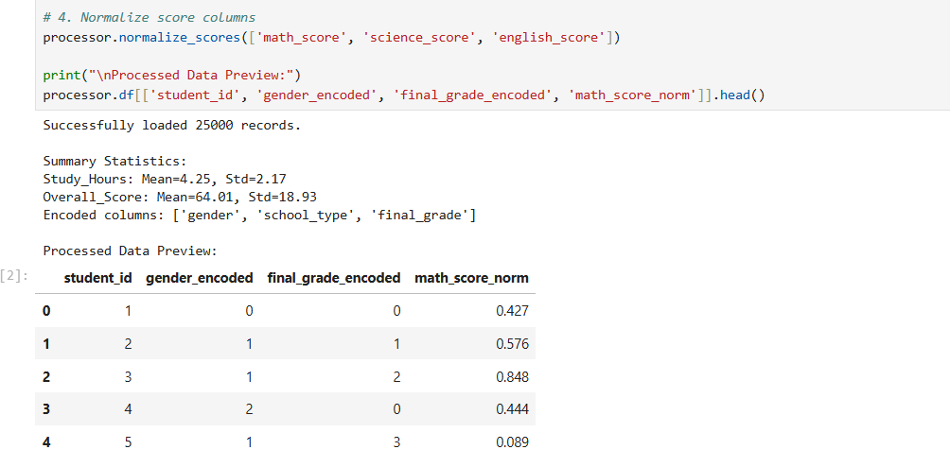

Step 5: Reusability Showcase
Demonstrate the module's flexibility by filtering the processed DataFrame to isolate students with attendance above 90% and computing their average overall score — all without modifying any class code.
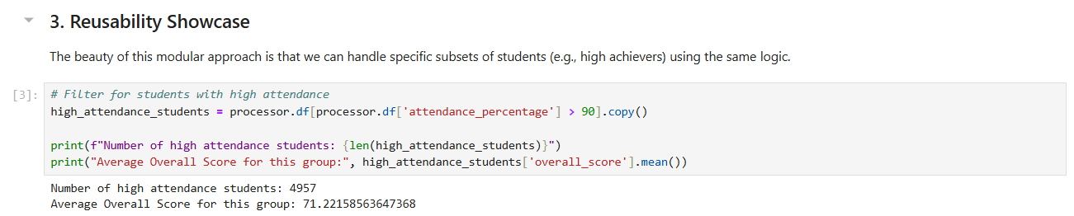
Step 6: Conclusion & KPIs
Summarize the module's performance across three KPIs: Code Efficiency through vectorized pandas operations, Reusability through methods applicable to any column without code changes, and Object-Oriented Structure that keeps all data state within the instance.
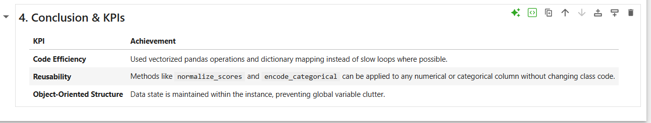

Lab No 9: Decision Tree
1. Introduction
Modern telemarketing campaigns suffer from incredibly low conversion rates when agents dial leads at random. For a financial institution attempting to sell a term deposit, a scattergun approach burns through operational budgets and agitates the consumer base. Instead of calling every number in the directory, sales teams need an empirical way to filter the high-value prospects from the guaranteed rejections.
The Decision Tree algorithm provides a highly transparent classification mechanism for exactly this scenario. Unlike "black-box" models, a Decision Tree mirrors human logic by splitting data along a series of yes-or-no conditions. It exposes the exact demographic and financial thresholds—such as specific account balances or marital status splits—that dictate purchasing behavior. In this module, we construct a full predictive pipeline to score prospective buyers, leveraging the algorithm’s transparent branches to extract actionable sales logic.
2. Problem Statement
A retail bank is looking to optimize its outbound call center operations for a newly launched term deposit product. Currently, the team operates without predictive intelligence, resulting in thousands of wasted hours calling customers who possess zero statistical probability of subscribing. The marketing director requires a classification model that evaluates historical campaign data to preemptively score the likelihood of a purchase. Successfully mapping out these buyer personas will allow the institution to isolate their outreach exclusively to high-propensity targets, directly improving overall financial yield.
3. Dataset Description
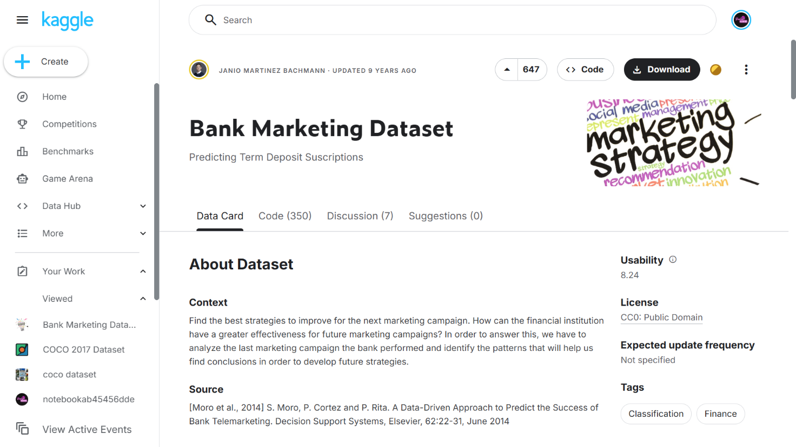 During this practical session, analysts will utilize the Marketing Dataset (bank.csv), which logs the complete outcomes of previous telemarketing drives. To build an accurate classifier, you must understand the underlying feature architecture:
- Demographic Anchors: Attributes including age, job, marital, and education map out the social profile of the customer.
- Financial Standing: Continuous metrics like balance alongside categorical flags like default, housing, and loan dictate the consumer’s available spending power.
- Engagement Metrics: Features such as campaign (number of contacts executed during this drive) track the level of sales effort already expended.
- Target Label: The deposit variable represents the definitive outcome of the sales pitch, serving as the binary target where "yes" signifies a successful conversion and "no" signifies a failure.
4. Tools Used
We rely on the KNIME Analytics Platform augmented by embedded Python scripting to construct this classifier. KNIME’s visual canvas easily handles bulk data ingestion, partitioning logic, and algorithm training without standard syntax overhead. However, native visual node outputs occasionally lack the specific formatting required for advanced metric reporting. To resolve this, we will deploy a Python Script node to directly calculate exact precision, recall, and F1-scores, demonstrating a highly effective hybrid approach to data science.
5. Practical Objectives
Upon successful completion of this laboratory module, students will prove practical competency by achieving the following learning outcomes:
- Isolate and remove problematic features (target leakage) that artificially inflate algorithm performance.
- Segment raw financial records into distinct training and testing blocks utilizing stratified sampling.
- Train and deploy a Decision Tree Learner to map logical splits across customer demographics.
- Embed native Python code directly into the visual pipeline to programmatically extract the Accuracy, Precision, Recall, and F1-score metrics.
- Translate these technical validation scores into an actionable business assessment.
6. Step-by-Step Procedure
Step 1: Data Ingestion and Target Leakage Removal (Data Preparation)
- Action: Load the historical marketing records and strip out variables that introduce algorithmic bias.
- Configuration: Drop a CSV Reader component onto the primary canvas and point it to the local bank.csv document. Wire its output into a Column Filter node. Open the filter settings and manually exclude the duration attribute. Since the duration of a sales call is only generated after the conversation ends, feeding it into a predictive model creates target leakage, severely distorting real-world accuracy.
- Execution: Execute both nodes to instantiate a sanitized baseline dataset.
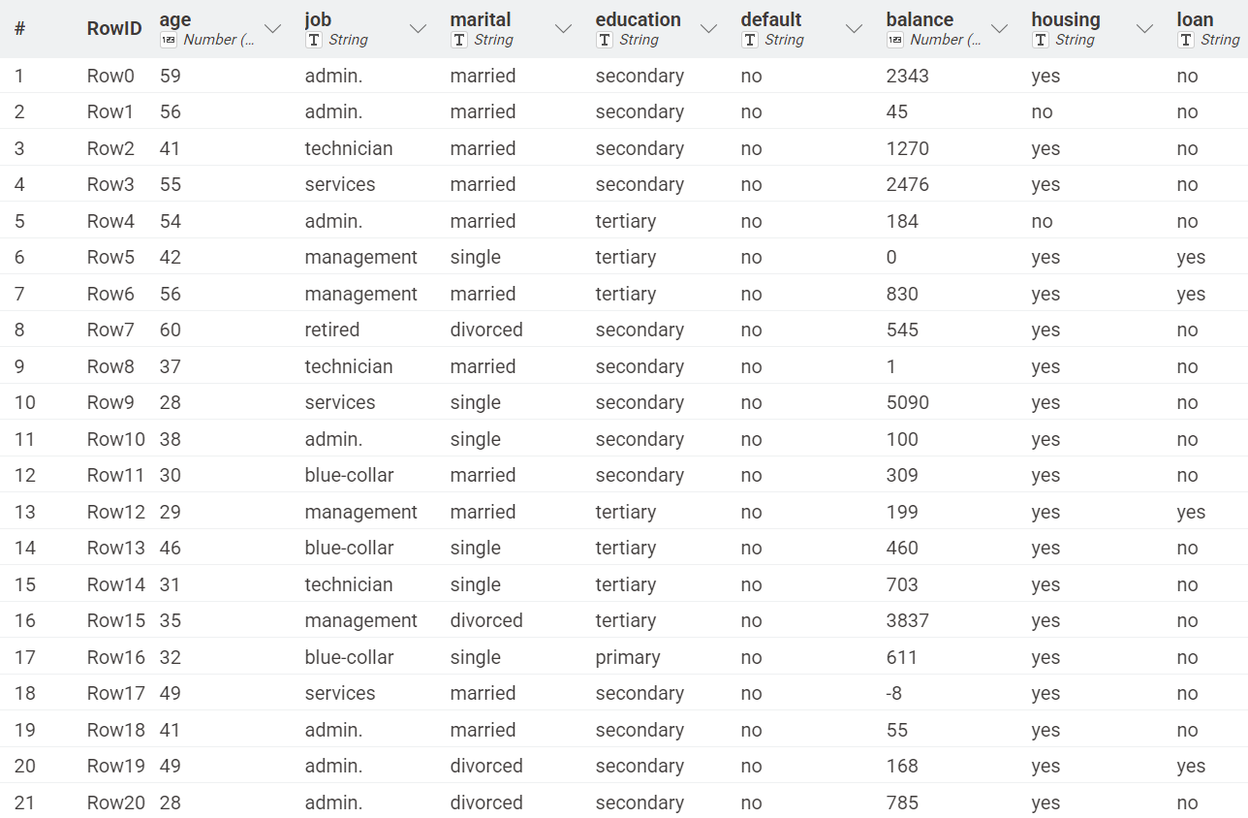
Step 2: Stratified Partitioning (Sampling)
- Action: Divide the ledger so the model retains historical instances to learn from while preserving unseen instances for unbiased testing.
- Configuration: Append a Partitioning node to the data stream. In the configuration panel, assign a relative split of 80% to the top training port and reserve 20% for the bottom testing port. Crucially, activate "Stratified sampling" and map it to the deposit column. This guarantees the mathematical ratio of buyers to non-buyers remains perfectly consistent across both splits.
- Execution: Apply the settings and run the node.
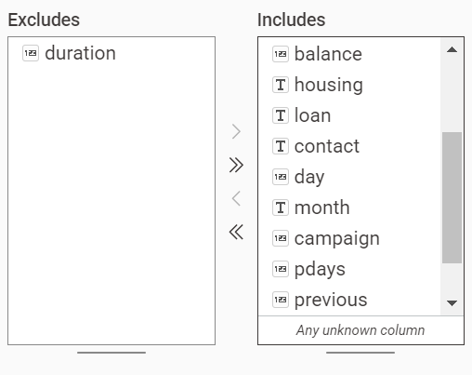

Step 3: Algorithm Training (Modeling)
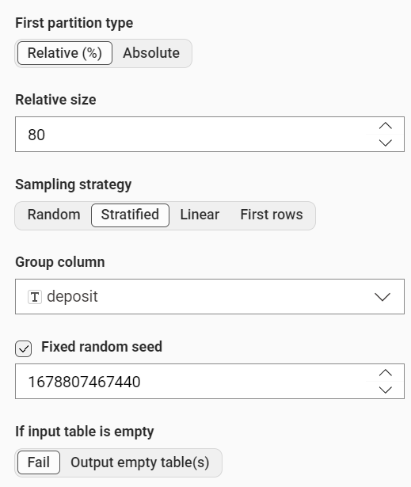
- Action: Grow the mathematical branches of the classifier by feeding it the historical training split.
- Configuration: Search the node repository for a Decision Tree Learner and place it onto the workspace. Wire the top output port of your Partitioning node directly into it. Inside the dialog, define the Class Column as deposit. Keep the Quality Measure set to "Gini Index" to enforce strict, high-purity informational splits.
- Execution: Right-click and execute the Learner. You may select "Decision Tree View" from the context menu to visually trace the exact demographic thresholds the algorithm prioritized at the root level.

Step 4: Executing Predictions (Validation)
- Action: Challenge the fully matured tree using your isolated testing records.
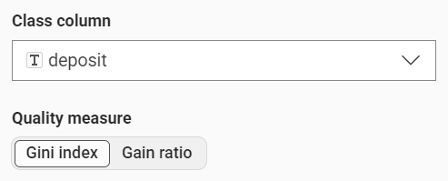
- Configuration: Bring a Decision Tree Predictor node onto the canvas. This operator demands dual inputs: route the blue modeling port from your Learner into the Predictor's upper blue port, and route the bottom testing flow (your 20% unseen split) into the standard data port.
- Execution: Execute the Predictor.
- Verification: Right-click the component to view the classified data. Verify that a novel column titled "Prediction (deposit)" has materialized next to the historical ground-truth outcomes.
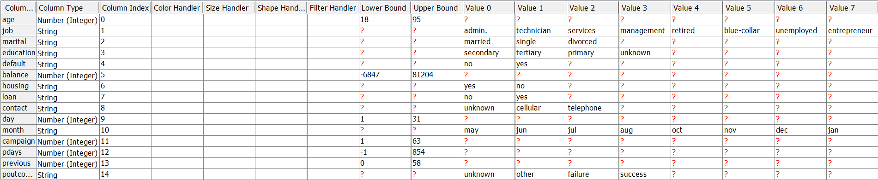

Step 5: Metric Extraction via Custom Scripting (Evaluation)
- Action: Bypass the platform's default scoring block to programmatically generate granular classification metrics.
- Configuration: Attach a Python Script node to the output port of the Predictor. Open the built-in code editor. We will utilize the sklearn.metrics library to mathematically compare the actual target values against our tree's predictions, tracking the "yes" class. Insert the following routine:
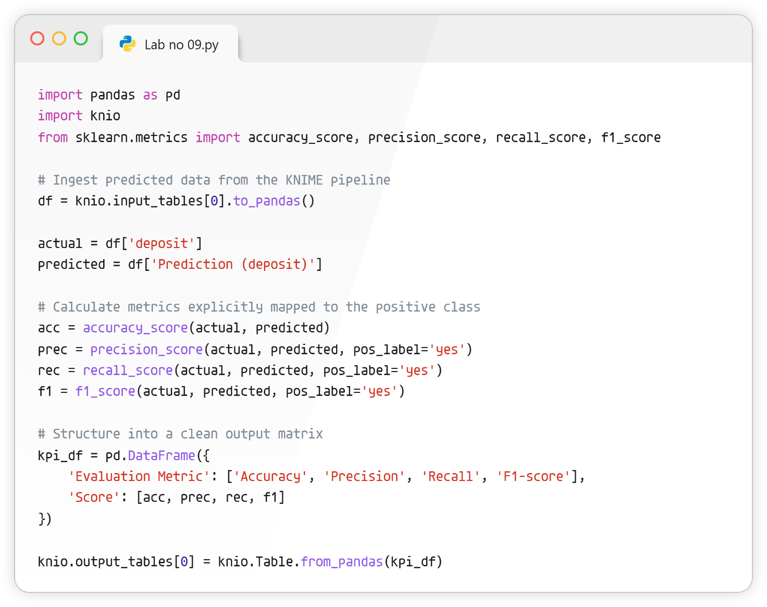
- Execution: Run the Python node.
- Verification: Open the integrated output table to review your formatted performance scorecard.
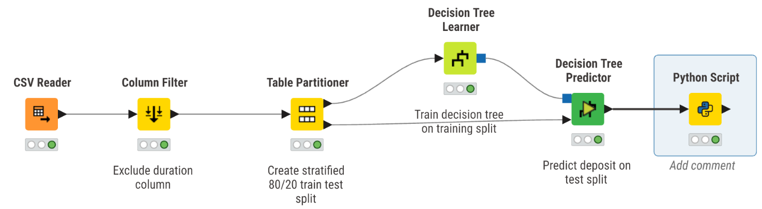
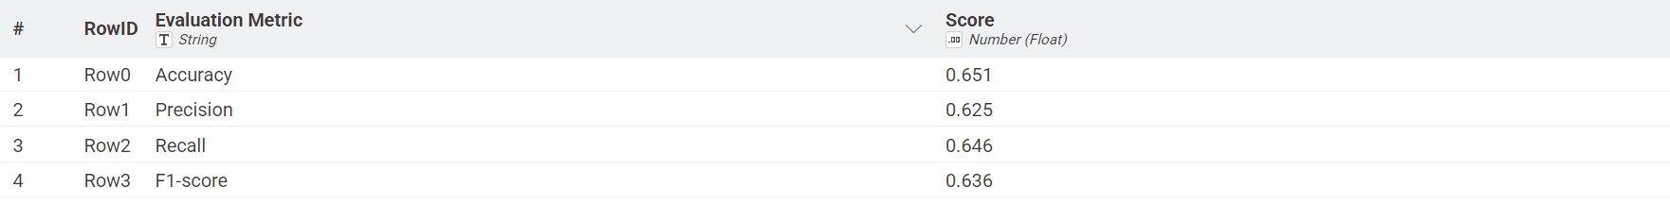
7. Key Performance Indicator (KPI) Calculations
To translate mathematical outputs into a deployable sales strategy, we extract and interpret four specific evaluation constraints generated by our script.
7.1 Accuracy
- Action: Gauge the aggregate classification correctness across both successful subscriptions and failed pitches.
- Calculation Method: (True Positives + True Negatives) / Total Analyzed Instances.
- Metric Extraction: Review the first row rendered by the Python script. While accuracy provides a rapid baseline, analysts must treat it cautiously here; overwhelming volumes of non-buyers can easily mask poor performance on the actual target demographic.
7.2 Precision
- Action: Determine the ultimate reliability of the algorithm's positive leads to prevent the sales floor from chasing false alarms.
- Calculation Method: True Positives / (True Positives + False Positives).
- Metric Extraction: Locate the second output row. An elevated precision indicates that when the algorithm flags a customer as a buyer, the sales agent can highly trust the viability of that lead.
7.3 Recall
- Action: Quantify the tree's capability to sweep the entire pool and capture potential buyers without letting targets slip past.
- Calculation Method: True Positives / (True Positives + False Negatives).
- Metric Extraction: Review the third output row. A degraded recall percentage proves the bank is leaving guaranteed revenue on the table by incorrectly discarding lucrative customers.
7.4 F1-score
- Action: Calculate the harmonic mean to establish a strict mathematical balance when precision and recall inevitably pull in opposite directions.
- Calculation Method: 2 * ((Precision * Recall) / (Precision + Recall)).
- Metric Extraction: Evaluate the final row of the script output. This blended score acts as the definitive, rigorous benchmark required by executives before pushing the predictive model live.
8. KPI Summary Table
The matrix below condenses the technical integration utilized to compute the marketing evaluation metrics:
KPI Name | Calculation Method | KNIME / Python Modules Utilized
Accuracy | Total correct classifications over total instances | Python Script (accuracy_score)
Precision | True positive ratio against all predicted positives | Python Script (precision_score)
Recall | True positive ratio against all actual positives | Python Script (recall_score)
F1-score | Harmonic mean combining precision and recall | Python Script (f1_score)
Conclusion
This finalizes our module on targeted marketing analytics via Decision Trees. We successfully constructed an end-to-end classification pipeline, from stripping bias-inducing parameters and structuring stratified splits, to leveraging hybrid Python scripting for advanced validation. The resulting logic supplies financial management with an empirical, data-backed mechanism to immediately maximize telemarketing efficiency.

Lab No 10: Naïve Bayes & K-Nearest Neighbors (KNN)
1. Introduction
Every day, our inboxes are bombarded with unsolicited, promotional, and sometimes malicious messages. We call it spam, and without automated filters, email as a communication tool would be virtually unusable.
Machine learning is the engine behind these automated filters. By training algorithms to recognize the subtle linguistic patterns and structural red flags typical of junk mail, we can automatically route these messages away from the user. In this laboratory exercise, you will step into the role of a data scientist tasked with building one of these filters. We will explore two foundational classification algorithms: Naïve Bayes and K-Nearest Neighbors (KNN). By the end of this session, you will understand how these models evaluate text data differently and how to directly compare their effectiveness in separating legitimate emails (ham) from the junk (spam).
2. Problem Statement
Imagine a growing email service provider struggling to keep its users' inboxes clean. Their current rule-based filtering system is failing because spammers constantly adapt their tactics, bypassing rigid keyword blocks. The provider urgently needs a dynamic, probabilistic approach to evaluate incoming mail.
The challenge is to build a classification pipeline that can "read" the raw text of an email and predict its likelihood of being spam. Management has requested a comparative study of two algorithms—Naïve Bayes (which relies on probability and word frequencies) and KNN (which classifies based on similarity to past examples). The goal is to determine which algorithm offers the best balance of overall accuracy and a strictly minimized False Positive Rate, as sending a crucial business email to the spam folder is a critical failure for the provider.
3. Dataset Description
For this exercise, we will utilize the Email spam.csv dataset. This file acts as our historical ledger, containing real-world email texts that have already been manually reviewed and labeled for machine learning purposes.
To successfully engineer our spam detector, you need to familiarize yourself with the two primary attributes in this dataset:
- text: The raw text content of the email. This is unstructured string data containing the actual message, promotional pitches, and standard conversational phrasing.
- spam: A binary integer column where 1 indicates the email is unsolicited junk, and 0 indicates it is legitimate mail. This serves as our target variable for the classification algorithms.
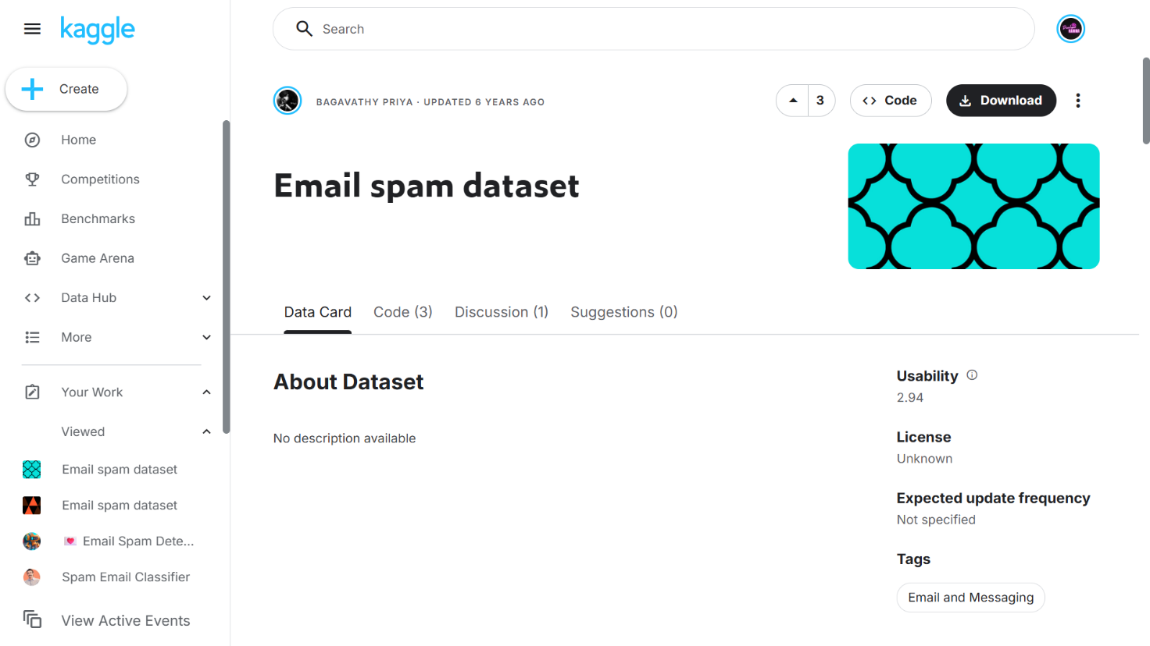
4. Tools Used
This lab requires a hybrid analytical approach, leveraging both RapidMiner Studio and Python.
- RapidMiner Studio: This visual workflow environment will serve as our primary pipeline builder. Its operator-based interface allows us to seamlessly ingest the data, process the unstructured text (handling tokenization and stop-word removal), and visually wire up our machine learning models without writing extensive code.
- Python: We will integrate Python scripting (via RapidMiner’s "Execute Python" operator) to handle advanced validation. Python allows us to strictly calculate custom metrics—specifically pinpointing the False Positive Rate—and to generate comparative statistical arrays that executives require before pushing a model live.
5. Practical Objectives
Upon successful completion of this laboratory session, you will demonstrate practical competency in text classification by achieving the following outcomes:
- Text Preprocessing: Transform unstructured email bodies into a structured matrix of word frequencies utilizing techniques like tokenization, case transformation, and TF-IDF weighting.
- Algorithm Implementation: Configure, train, and deploy both a Naïve Bayes classifier and a K-Nearest Neighbors (KNN) model on the processed text.
- Model Validation: Apply data splitting to ensure both models are evaluated on unseen testing data, preventing overfitting and ensuring real-world reliability.
- Comparative Analysis: Extract and strictly compare evaluation metrics—specifically Accuracy and False Positive Rate—to determine the safest, most effective model for a production environment.
6. Step-by-Step Procedure
Step 1: Workspace Initialization
Launch RapidMiner Studio. Begin by creating a new, blank process canvas and assign it a descriptive title, such as "Spam_Detection_NB_vs_KNN". This blank workspace will host your entire text-mining pipeline.
Step 2: Importing the Dataset
Locate the "Read CSV" operator in your repository panel and drag it onto the canvas. Use the Import Configuration Wizard to locate your Email spam.csv file. It is crucial here to ensure the spam column is imported as a "binominal" type and explicitly set its role to "label". This tells RapidMiner exactly which variable you are trying to predict. Ensure the text column is cast as "text".
Step 3: Text Preprocessing
Machine learning models require numerical input, not raw paragraphs. Drag a "Process Documents from Data" operator onto the canvas and connect your dataset to it. Double-click this operator to open its internal workflow. Inside, build the following sequence:
- Tokenize: To chop the email bodies into individual words.
- Transform Cases: Configure this to make all text lowercase (ensuring "Free" and "free" are analyzed as the exact same word).
- Filter Stopwords (English): To strip out common filler words (like "the", "and", or "is") that carry no predictive weight.
- Generate n-Grams (Optional): To capture word pairs that might indicate spam when grouped together.
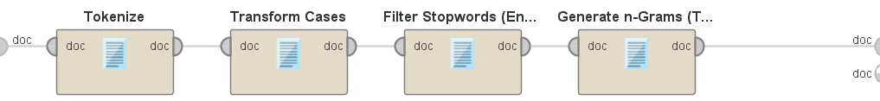
Return to the main process canvas once this inner pipeline is complete.
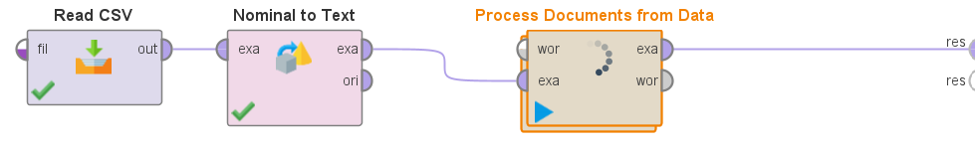
Step 4: Data Splitting and Model Implementation
To rigorously evaluate our models, we must test them on data they haven't seen during training. Add a "Split Data" operator, partitioning 70% of your data for training and the remaining 30% for testing.
Next, build two parallel testing branches (using a "Multiply" operator to feed the training data to both):
- Branch A (Naïve Bayes): Drag the "Naïve Bayes" operator onto the canvas and connect it to your training split.
- Branch B (KNN): Drag the "k-NN" operator onto the canvas. Set your 'k' parameter to a starting baseline of 5.
For each branch, connect the trained model and your 30% testing data split into an "Apply Model" operator. 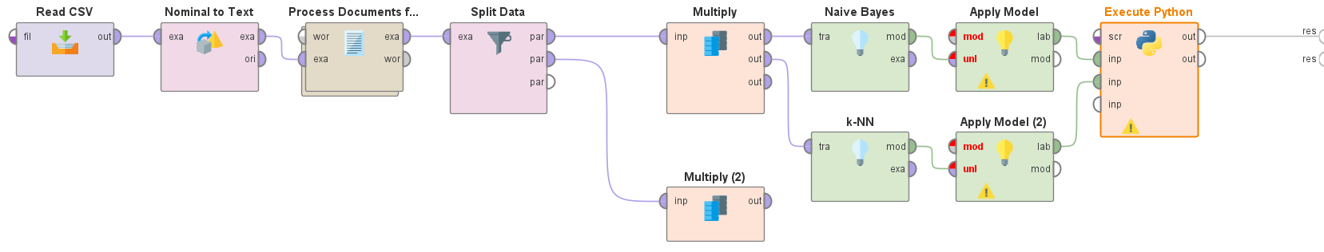
Step 5: Performance Evaluation via Python Integration
Connect the outputs of your "Apply Model" operators to an "Execute Python" operator. Inside the Python script window, import sklearn.metrics. Write a script to calculate the exact harmonic balance of your predictions, ensuring your code specifically references the spam column as the true target. Extract the accuracy_score and generate a confusion_matrix to isolate the exact count of False Positives. Output these variables as a structured data frame back to the RapidMiner results perspective.
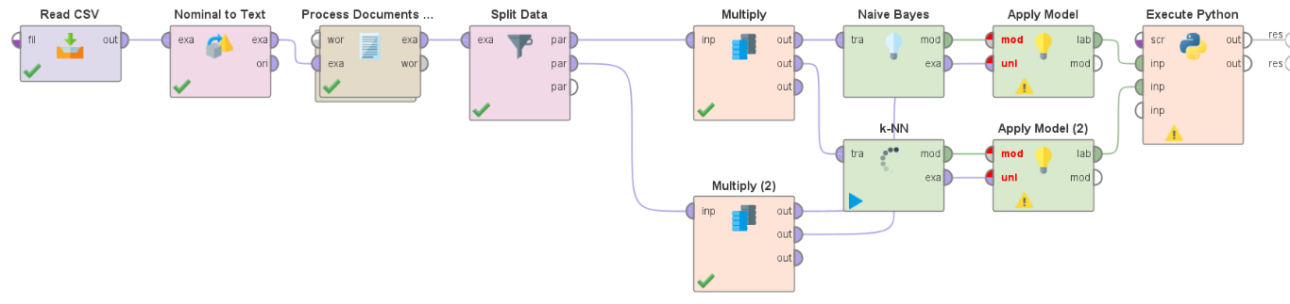
7. Interpretation Guidance
When evaluating your final results, you must think from the perspective of the email service provider:
- Accuracy shows the overall percentage of emails correctly classified. While a high number looks impressive, it does not reveal the whole operational story.
- False Positive Rate (FPR) is the absolute most critical metric in this scenario. A False Positive means a legitimate, potentially urgent email was flagged as spam and hidden from the user. If your Naïve Bayes model yields 95% accuracy but a 5% FPR, and your KNN yields 92% accuracy but a 0.5% FPR, the KNN is vastly superior for business use. Users will tolerate a few spam messages slipping into their inbox, but they will heavily penalize a provider that deletes their important mail.
8. KPI Summary Table
The matrix below condenses the technical integration utilized to compute your final evaluation metrics. You will fill in the exact results upon execution.
Evaluation Metric | Calculation Focus | RapidMiner / Python Implementation
Accuracy | Total correct classifications over total instances | Python Script (accuracy_score) / Performance Operator
False Positive Rate (FPR) | False Positives / (False Positives + True Negatives) | Python Script (confusion_matrix)
Algorithm Speed | Computational time required to parse and score text | RapidMiner Execution Timer
Conclusion
This finalizes our module on text mining and algorithm comparison. We successfully constructed an end-to-end classification pipeline, transitioning from raw, unstructured text to a clean numerical matrix. By leveraging RapidMiner for structural flow and Python for rigorous metric extraction, we established an empirical, data-backed mechanism to determine whether Naïve Bayes or KNN serves as the safer, more efficient engine for enterprise spam detection.

Lab No 11: Support Vector Machine (SVM) for Credit Card Fraud Detection
1. Introduction
In the contemporary digital economy, the proliferation of instantaneous credit card transactions is paralleled by increasingly sophisticated methods of financial fraud. For banking institutions, distinguishing between legitimate consumer behavior and unauthorized, anomalous activity is a high-stakes classification problem. Traditional, rule-based security systems frequently fail in this domain, either generating an excess of false positive alarms—which disrupt the customer experience—or allowing subtle fraud patterns to bypass detection.
Unlike probabilistic models (such as Naïve Bayes) or rudimentary distance-based heuristics (such as K-Nearest Neighbors), a Support Vector Machine (SVM) operates as an advanced geometric classifier. The algorithm maps historical transaction records as coordinates within a high-dimensional feature space and attempts to construct an optimal hyperplane—a mathematical boundary—that maximizes the geometric margin between distinct classes (fraudulent versus legitimate).
When transactional behaviors are clearly distinct, a standard Linear kernel efficiently separates the classes. However, financial anomalies are frequently entangled with normal spending patterns, making them non-linearly separable. To resolve this, SVM algorithms employ a mathematical transformation known as the "kernel trick," utilizing a Radial Basis Function (RBF) to project the data into an even higher dimension where a distinct boundary can be established. This laboratory session introduces students to SVM optimization, demonstrating how to properly encode categorical data, configure hyperplane margins, and evaluate kernel performance within a highly imbalanced financial dataset.
2. Problem Statement
A global financial institution processes millions of credit card transactions daily. Currently, their security division relies on outdated, static thresholds to flag suspicious activity, resulting in high financial losses from undetected fraud and severe operational fatigue from investigating false alarms. The analytics department requires a robust, machine-learning-driven classification framework capable of analyzing complex customer profiles and isolating fraudulent anomalies with high precision.
The core challenge lies in the severe class imbalance inherent to fraud data; legitimate transactions vastly outnumber fraudulent ones. The organization needs to engineer a predictive pipeline that not only identifies the optimal mathematical boundary separating these classes but also correctly prioritizes the capture of actual fraud (Recall) without indiscriminately blocking valid customer purchases (Precision).
3. Dataset Description
For this laboratory exercise, students will utilize the Credit Card Fraud Detection Dataset (provided as data2.csv). This dataset serves as a historical financial ledger, capturing demographic and transactional metadata for recent credit card activity.
To successfully engineer the SVM classifier, analysts must evaluate the following foundational attributes:
- Profession: A categorical string variable indicating the cardholder's occupational sector (e.g., DOCTOR, LAWYER, ENGINEER).
- Income: A continuous integer representing the cardholder's annual financial earnings.
- Credit_card_number, Expiry, Security_code: Granular, high-cardinality metadata associated with the specific transaction. Because these are unique identifiers rather than predictive behavioral traits, they act as noise and must be excluded to prevent algorithmic overfitting.
- Fraud: The binary target variable for supervised learning. A value of 1 confirms the transaction was fraudulent, while a value of 0 indicates a legitimate purchase.
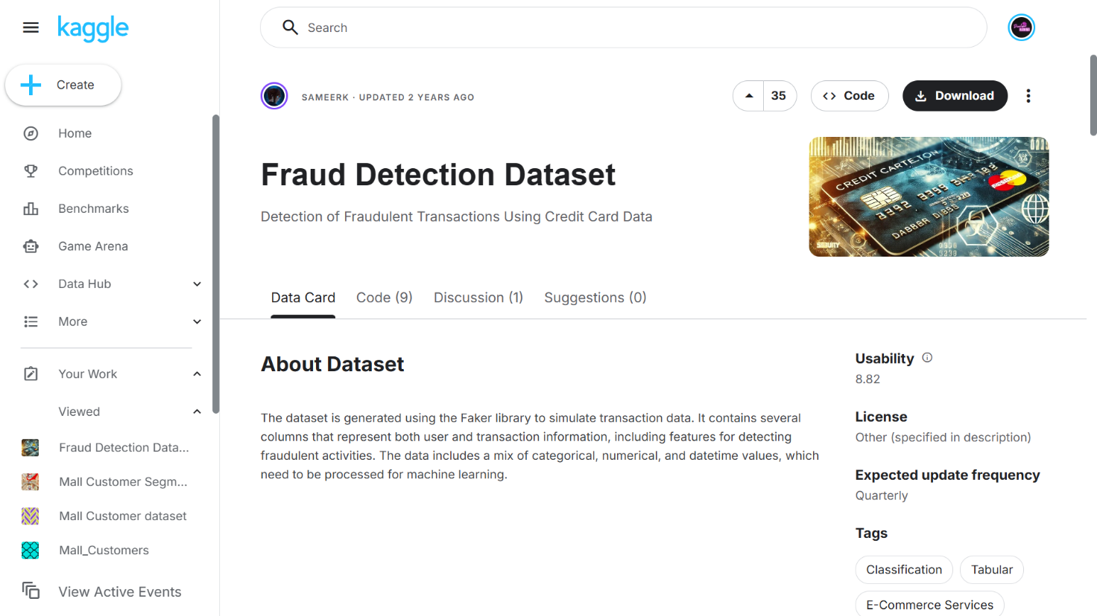
4. Tools Used
This procedure relies on a hybrid data science architecture integrating the KNIME Analytics Platform with embedded Python scripting.
KNIME provides a visually transparent, node-based environment ideal for executing essential data preparation tasks, such as one-hot encoding, mathematical normalization, and stratified partitioning. Native KNIME nodes will also handle the computationally heavy training of the SVM models. However, to bypass visual limitations and extract highly specific mathematical evaluation metrics (such as ROC-AUC on imbalanced targets), students will deploy a Python Script node leveraging the scikit-learn (sklearn.metrics) library. This dual-tool framework combines rapid structural prototyping with granular algorithmic evaluation.
5. Practical Objectives
Upon successful completion of this laboratory module, students will demonstrate practical competency by achieving the following learning outcomes:
- Preprocess mixed-type financial data by deploying one-hot encoding for categorical variables and Min-Max normalization for continuous financial metrics, ensuring mathematical compatibility with the SVM algorithm.
- Implement stratified data partitioning to preserve the precise statistical ratio of the minority fraud class across training and testing splits.
- Train and deploy distinct Support Vector Machine classifiers utilizing both Linear and Radial Basis Function (RBF) kernels.
- Embed native Python syntax into the visual workflow to programmatically calculate precision, recall, and ROC-AUC metrics.
- Interpret classification metrics to deduce the most effective kernel approach for minimizing financial risk.
6. Step-by-Step Procedure
Step 1: Data Ingestion and Noise Filtration (Data Preparation)
- Action: Load the raw transaction ledger and discard high-cardinality identifiers that introduce computational noise and bias into the geometric space.
- Configuration: Drag a CSV Reader node onto the canvas and target the data2.csv file. Next, append a Column Filter node to the output port. Inside the configuration dialog, forcefully exclude the Credit_card_number, Expiry, and Security_code columns.
- Execution: Execute the nodes to isolate the predictive features (Profession, Income, and Fraud).
- Verification: Right-click the Column Filter and open the output table to confirm the removal of the specific identifiers.
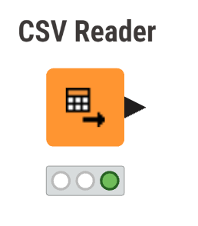
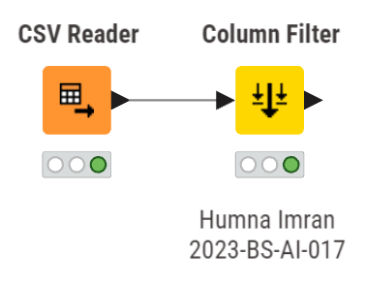
Step 2: Target Type Conversion and One-Hot Encoding
- Action: Format the dataset to meet the strict numerical input requirements of the SVM algorithm while designating the target label for classification.
- Configuration: Connect a Number to String node to cast the Fraud column from an integer to a categorical class (required for classification algorithms). Subsequently, attach a One to Many node. Configure it to evaluate the Profession column. This operation will convert the categorical text strings into discrete binary columns (e.g., Profession_DOCTOR, Profession_LAWYER), providing the SVM with purely numerical features.
- Execution: Process the pipeline through the encoding stage.
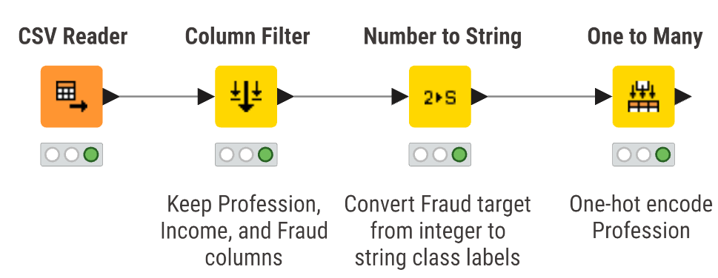
Step 3: Feature Normalization
- Action: Standardize the massive variance in the Income variable. Without normalization, large numerical values will mathematically dominate the distance calculations within the SVM’s feature space, skewing the hyperplane.
- Configuration: Append a Normalizer node. Select the Income column and configure the method to "Min-Max Normalization" bounded between 0.0 and 1.0.
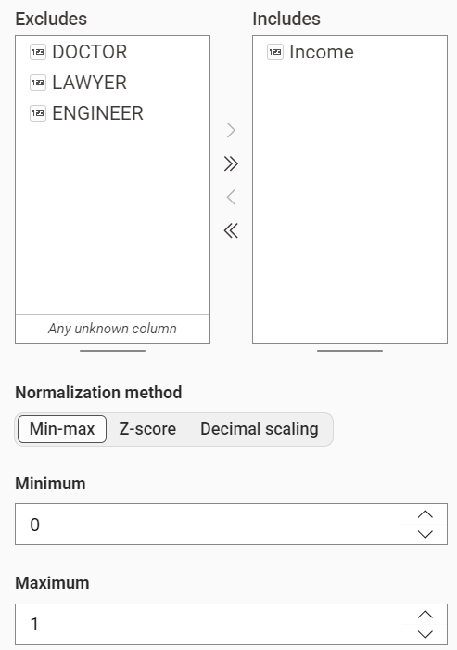

Step 4: Stratified Partitioning
- Action: Segment the data into isolated training and testing blocks, explicitly forcing the algorithm to distribute the rare fraudulent cases evenly across both datasets.
- Configuration: Add a Partitioning node. Define the relative size as 80% (0.8). Crucially, check the box for "Stratified sampling" and select the Fraud column as the strata.
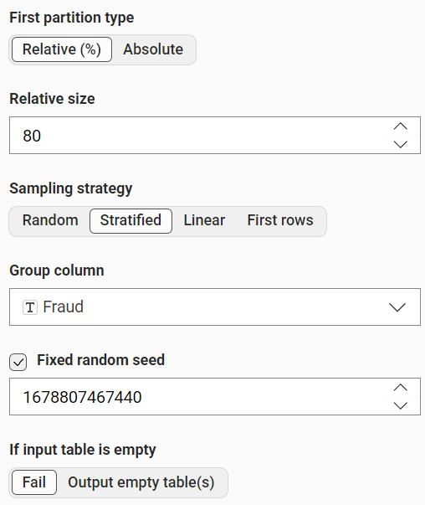
Step 5: Training the Support Vector Machines (Modeling)
- Action: Construct two independent mathematical boundaries using different kernel geometries to separate the fraud cases from the legitimate transactions.
- Configuration: Bring two separate SVM Learner nodes onto the workspace. Wire the top (training) output port of the Partitioning node into both Learners.
  - Learner A: Double-click and set the Target Column to Fraud. Assign the Kernel Type to "Linear".
  - Learner B: Double-click and set the Target Column to Fraud. Assign the Kernel Type to "RBF" (Radial Basis Function).
- Execution: Execute both learners simultaneously. The nodes will calculate the support vectors defining the hyperplane limits.
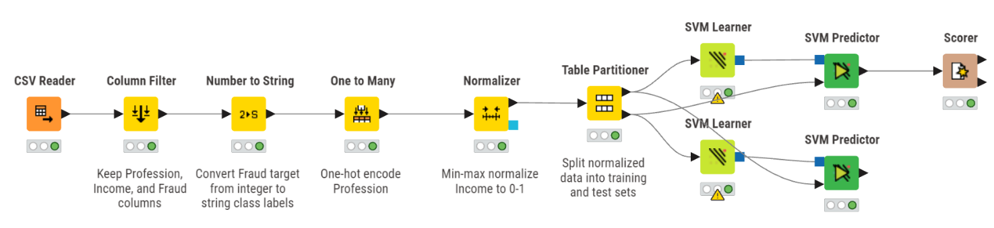
Step 6: Executing Predictions and Python Evaluation (Validation)
- Action: Score the unseen testing transactions and programmatically extract specific fraud-detection metrics using Python logic.
- Configuration: Deploy two SVM Predictor nodes. For each, connect the blue model output from the respective Learner to the top port, and the bottom testing output of the Partitioning node to the second port.
- Metric Extraction: Finally, funnel the output table from the Predictor nodes into a single Python Script node. Within the script editor, import sklearn.metrics. Write a brief script utilizing roc_auc_score, precision_score, and recall_score, specifically assigning the positive label to the string "1" (representing actual fraud).
- Verification: Review the Python Script's standard output to compare the numerical performance of the Linear versus the RBF configurations.
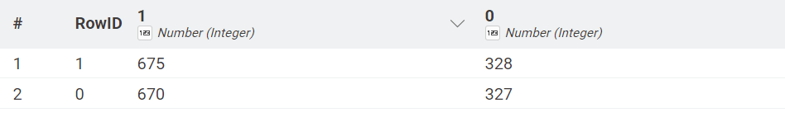
7. Key Performance Indicator (KPI) Calculations
To translate algorithmic outputs into a coherent security strategy, analysts must evaluate the model against standard business intelligence KPIs.
7.1 Recall (Fraud Capture Rate)
- Action: Measure the model's absolute capability to identify fraudulent behavior, ensuring no malicious transactions escape the filter.
- Calculation Method: True Positives / (True Positives + False Negatives).
- Metric Extraction: Utilizing the recall_score parameter within the Python script. In a banking context, maximizing Recall is generally prioritized over general accuracy, as a single missed fraudulent transaction (False Negative) carries significant financial penalties.
7.2 Precision (Alarm Accuracy)
- Action: Quantify the validity of the fraud alerts generated by the model to prevent the suspension of legitimate customer accounts.
- Calculation Method: True Positives / (True Positives + False Positives).
- Metric Extraction: Utilizing the precision_score parameter. While capturing fraud is vital, an excessively aggressive model with low Precision will freeze valid customer funds, leading to customer churn and reputational damage.
7.3 ROC-AUC (Receiver Operating Characteristic - Area Under Curve)
- Action: Evaluate the aggregate capability of the SVM kernels to separate the positive and negative classes across all possible decision thresholds.
- Calculation Method: The geometric area calculated under the True Positive Rate vs. False Positive Rate curve.
- Metric Extraction: Utilizing the roc_auc_score parameter. A score closer to 1.0 indicates near-perfect class separation, definitively proving whether the complex boundaries of the RBF kernel outperform the flat boundaries of the Linear kernel on this dataset.
8. KPI Summary Table
The matrix below condenses the technical integration utilized to compute your final evaluation metrics upon execution.
KPI Name,Calculation Method,KNIME / Python Modules Utilized
Recall,True positive ratio against all actual positive fraud cases,Python Script (recall_score)
Precision,True positive ratio against all predicted fraud flags,Python Script (precision_score)
ROC-AUC,Aggregate area indicating total class separability,Python Script (roc_auc_score)
9. Conclusion
This finalizes the laboratory module on advanced geometric classification via Support Vector Machines. We successfully engineered an end-to-end predictive pipeline that ingested raw financial ledgers, programmatically encoded non-numeric occupational parameters, and geometrically scaled financial features to construct a balanced training space. By deploying and evaluating both Linear and RBF mathematical kernels alongside hybrid Python scripting, analysts can empirically determine the safest, most precise algorithmic boundary required to automate enterprise-scale fraud detection systems.

Lab No 12: Customer Segmentation
1. Introduction
In the contemporary retail sector, treating an entire consumer base as a single homogenous entity is highly inefficient. Different shoppers exhibit radically different purchasing behaviors, driven by their unique financial standing and personal preferences. Customer segmentation, a practical application of unsupervised machine learning, resolves this by algorithmically discovering hidden, natural groupings within transactional and demographic data. By utilizing clustering techniques like K-Means and Hierarchical Clustering, organizations can partition their audience into highly specific buyer personas.
This laboratory module guides students through the end-to-end process of unsupervised data mining. By constructing distance matrices and plotting geometric cluster boundaries, analysts will learn how to identify high-value customer segments, allowing retail management to deploy hyper-targeted marketing campaigns and optimize overall resource allocation.
2. Problem Statement
A prominent shopping mall wishes to modernize its promotional outreach. Currently, marketing budgets are distributed blindly across all registered shoppers, resulting in poor engagement and wasted financial resources. The marketing director urgently requires a mathematical breakdown of their clientele based on earning capacity and mall spending habits.
The core challenge lies in the fact that the data is unlabelled; there are no predefined categories or target variables to predict. The analytics team must deploy unsupervised learning algorithms to autonomously discover the optimal number of consumer profiles. By successfully extracting these distinct segments, the mall can identify which specific group yields the highest financial return and tailor bespoke loyalty programs to maximize profitability.
3. Dataset Description
This laboratory utilizes the Mall Customer Dataset (store_customers.csv), which serves as a demographic and behavioral ledger for the shopping center's registered patrons. To successfully map the clustering algorithms, students must familiarize themselves with the following attributes:
- CustomerID: A unique sequential identifier. As this holds no behavioral value, it acts as mathematical noise and must be explicitly excluded during the modeling phase.
- Gender & Age: Standard demographic features providing context to the buyer profiles.
- Annual Income (k$): A continuous numerical variable representing the estimated yearly earnings of the customer, acting as a direct proxy for their overall purchasing power.
- Spending Score (1-100): A proprietary metric assigned by the mall based on historical purchasing frequency and volume. A score closer to 100 dictates a highly active, lucrative shopper.
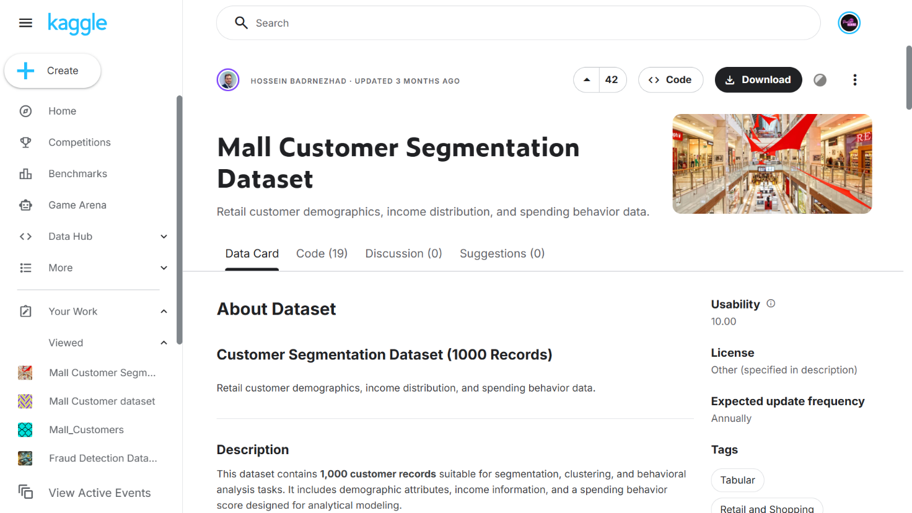
4. Tools Used
This procedure relies on a hybrid analytical architecture integrating Orange Data Mining with Python scripting. Orange provides an intuitive, visual canvas that is exceptionally well-suited for exploratory unsupervised learning. Its drag-and-drop widgets allow analysts to effortlessly construct distance-based dendrograms and generate interactive scatter plots to visualize cluster boundaries.
However, to bypass visual limitations and programmatically extract rigorous evaluation heuristics (such as the Silhouette Score), students will utilize Python and its scikit-learn library. This dual-tool methodology ensures both a deep conceptual understanding of the geometric groupings and precise mathematical validation.
5. Practical Objectives
Upon successful completion of this laboratory session, students will demonstrate practical competency by achieving the following learning outcomes:
- Ingest and preprocess the unlabelled mall dataset, correctly isolating continuous numerical features for distance-based clustering.
- Construct a Hierarchical Clustering dendrogram to visually deduce the optimal number of structural segments.
- Deploy the K-Means clustering algorithm to mathematically partition the customer base into distinct buyer personas.
- Generate multidimensional scatter plots to visualize the geometric separation of the clustered data.
- Embed Python scripting to calculate the Silhouette Score and quantify the Cluster Revenue Contribution, translating geometric groupings into actionable business intelligence.
6. Step-by-Step Procedure
Step 1: Data Ingestion and Feature Isolation (Data Preparation)
- Action: Import the customer ledger and restrict the feature space strictly to the financial metrics to prevent demographic noise from skewing the geometric distances.
- Configuration: Drop a File widget onto the Orange canvas and load the store_customers.csv document. Connect its output to a Select Columns widget. Inside the configuration interface, relegate CustomerID, Gender, and Age to the "Meta" or "Ignored" domain. Keep only Annual Income (k$) and Spending Score (1-100) in the active "Features" domain.
- Execution: Close the dialog to apply the structural schema.
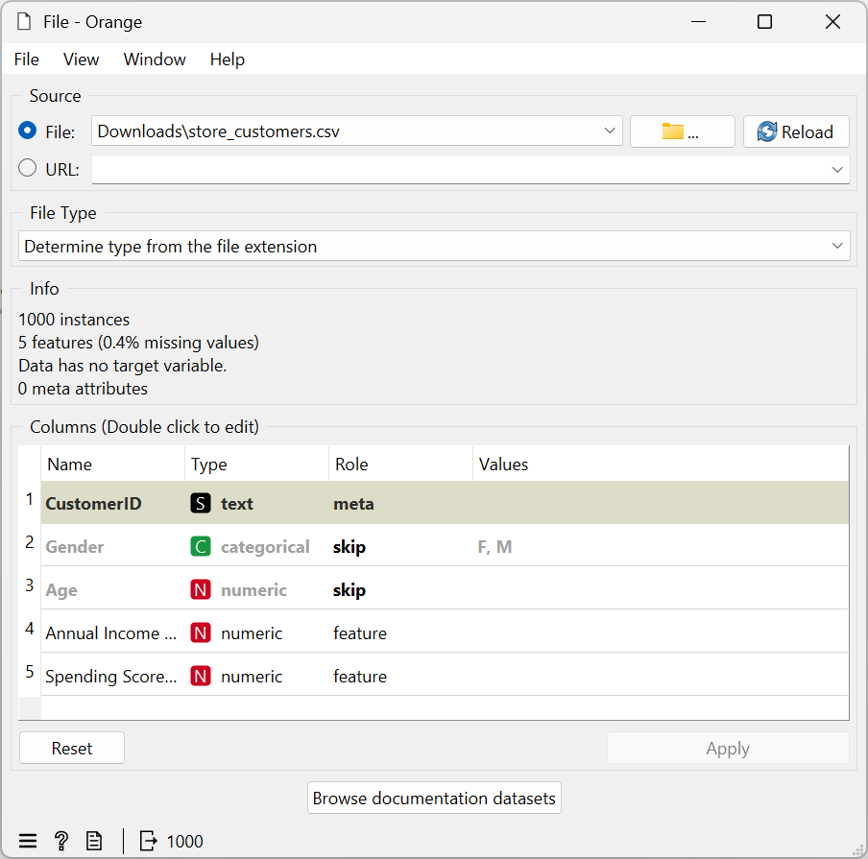
Step 2: Hierarchical Clustering and Dendrogram Construction (Exploration)
- Action: Calculate the geometric proximity between all shoppers and construct a visual tree to identify the natural algorithmic breaking points.
- Configuration: Connect a Distances widget to your Select Columns output, ensuring the distance metric is set to "Euclidean". Next, route the calculated distances into a Hierarchical Clustering widget. Use "Ward" as the linkage method to minimize variance within the branches.
- Verification: Double-click the Hierarchical Clustering node to view the generated dendrogram. By observing the length of the vertical branches, visually determine the optimal cut-off point. For this specific financial dataset, you should observe five distinct, major branches.
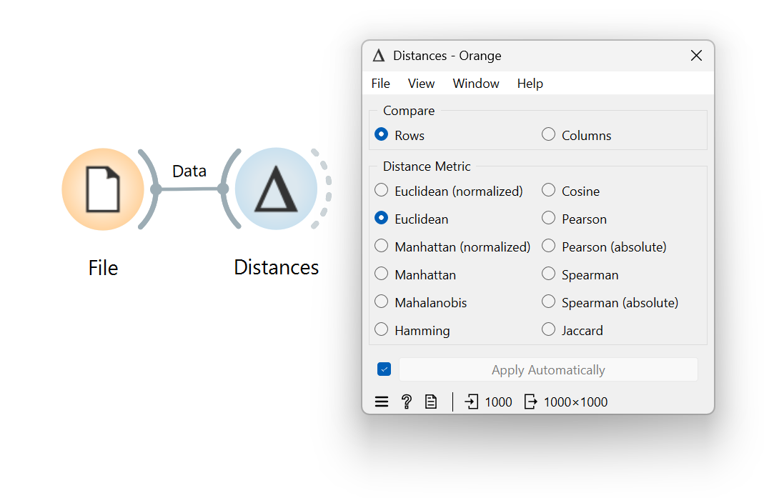
Step 3: K-Means Implementation (Modeling)
- Action: Formally partition the dataset using the optimal cluster count identified in the previous step.
- Configuration: Drag a K-Means widget onto the workspace and connect it directly to the Select Columns data stream. In the hyperparameter settings, fix the "Number of Clusters" (k) to 5.
- Execution: Allow the node to execute. The algorithm will iteratively update its centroids until convergence, successfully appending a new categorical 'Cluster' label (e.g., C1, C2, C3) to every individual customer record.
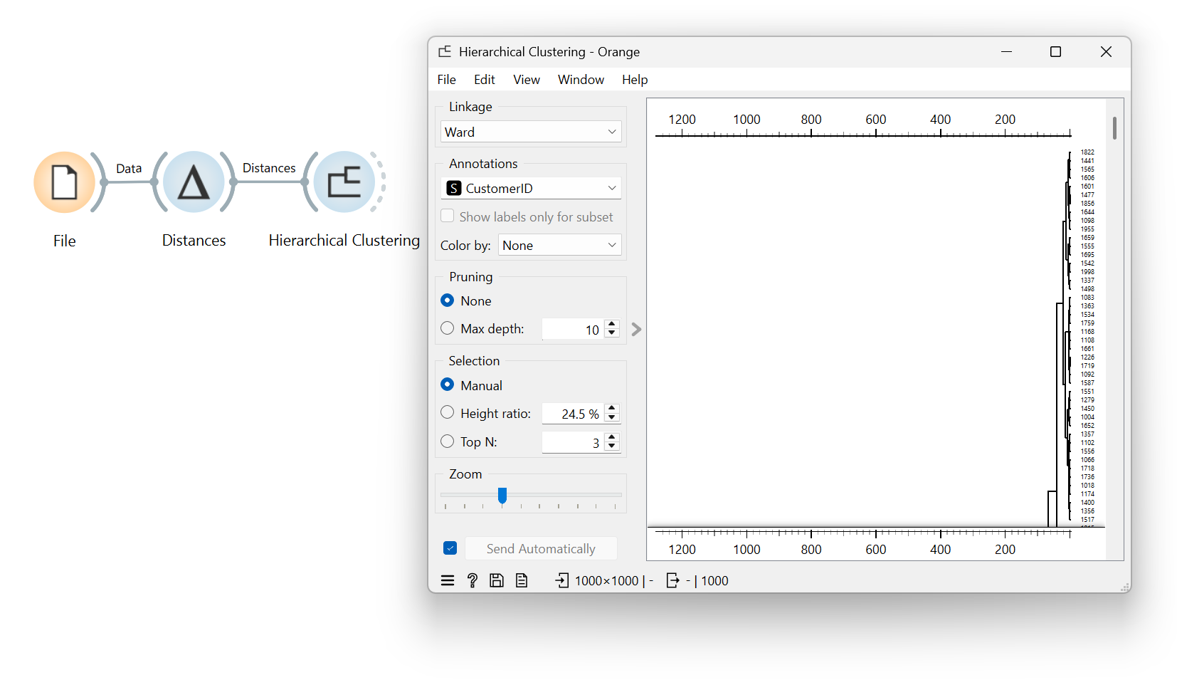
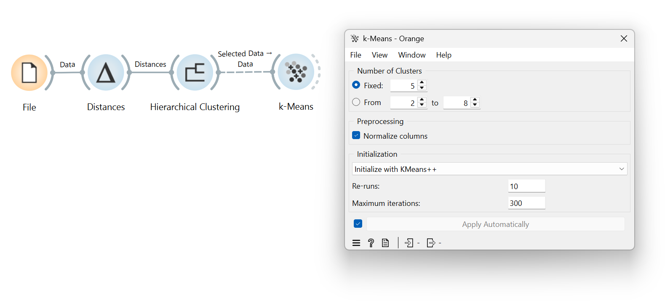
Step 4: Geometric Visualization (Deployment)
- Action: Render a visual representation of the customer segments to manually verify the algorithmic separation.
- Configuration: Append a Scatter Plot widget to the output port of the K-Means node. Assign Annual Income (k$) to the X-axis and Spending Score (1-100) to the Y-axis. Set the "Color" parameter to the newly generated 'Cluster' attribute.
- Verification: Inspect the scatter plot. You will clearly see five color-coded behavioral groups, such as a high-income/high-spend cluster (the target audience) and a low-income/low-spend cluster.
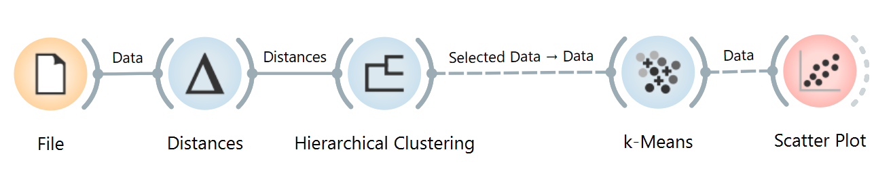
Step 5: Programmatic Validation (Python Evaluation)
- Action: Transition to code to extract the specific mathematical cohesion of the clusters and their real-world financial weight.
- Configuration: Within a Python IDE or a Jupyter Notebook, import the pandas and sklearn.metrics libraries. Load the dataset, apply the K-Means algorithm programmatically, and write a script to calculate the Silhouette Score. Furthermore, group the resulting dataframe by the cluster labels and sum the annual incomes to generate the revenue contribution metrics.
- Execution: Run the script and record the terminal outputs for your final reporting.
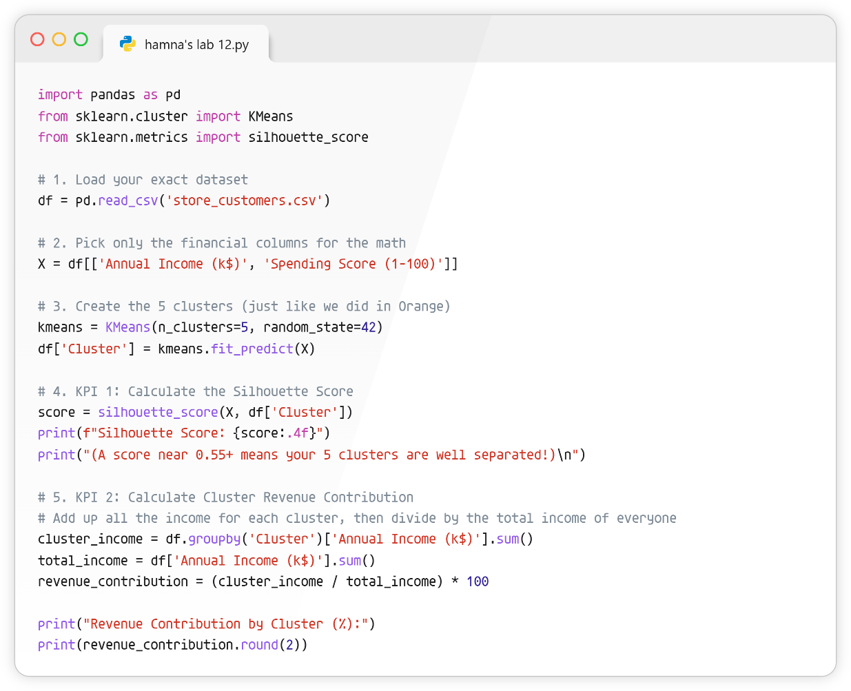
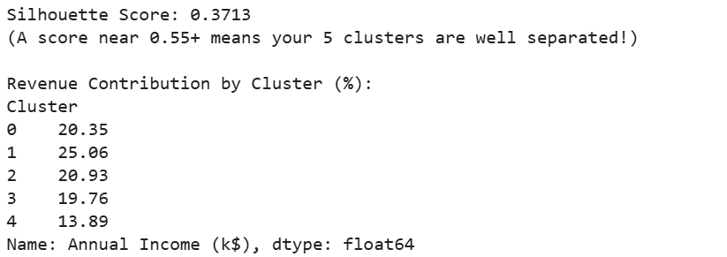
7. Key Performance Indicator (KPI) Calculations
To bridge the gap between abstract clustering geometries and actionable marketing intelligence, analysts must evaluate the newly formed segments against rigid mathematical and financial criteria.
7.1 Silhouette Score
- Action: Quantify the structural integrity of your K-Means model by measuring how tightly packed the clusters are and how well separated they are from neighboring groups.
- Calculation Method: Calculated programmatically as the mean silhouette coefficient for all samples. The metric ranges from -1.0 to 1.0.
- Code/Widget Extraction: Utilize the silhouette_score function from sklearn.metrics within your Python script. A score climbing toward 1.0 proves that the chosen k=5 parameter successfully found dense, highly distinct customer personas.
7.2 Cluster Revenue Contribution
- Action: Determine the overarching financial weight of each distinct buyer persona to dictate where the marketing budget should be aggressively deployed.
- Calculation Method: (Aggregate Annual Income of Specific Cluster / Total Annual Income of Entire Dataset) × 100.
- Code/Widget Extraction: Utilize the pandas library grouping functions in Python (e.g., df.groupby('Cluster')['Annual Income (k$)'].sum()) to derive the proportional percentage. This allows management to quickly isolate the "High-Income / High-Spend" demographic as their primary financial driver.
8. KPI Summary Table
The following matrix condenses the technical integration utilized to compute your final evaluation metrics for the unsupervised pipeline.
KPI Name | Calculation Method | Orange / Python Modules Utilized
Silhouette Score | Mean intra-cluster distance versus nearest-cluster distance | Python Script (sklearn.metrics.silhouette_score)
Cluster Revenue Contribution | (Sum of Cluster Income / Total Income) × 100 | Python Script (pandas groupby aggregation)

9. Conclusion
This finalizes the laboratory module on unsupervised machine learning and customer segmentation. We successfully engineered a data pipeline that ingested unlabelled retail ledgers, discarded demographic noise, and utilized distance-based heuristics to visually deduce optimal groupings via a dendrogram. By deploying the K-Means algorithm and validating the geometric outputs with Python-based Silhouette scoring, we transformed raw, unorganized shoppers into five distinct, actionable buyer personas. Armed with these specific profiles and their associated Revenue Contributions, the shopping mall's management can now confidently execute highly targeted, data-driven marketing campaigns to maximize their overall financial yield.
Lab No 13: Outlier Detection
1. Introduction
In the banking and financial sector, billions of data points are processed every single day. Most of this activity follows predictable, standardized patterns representing everyday consumer behavior. However, hidden within this massive volume of normal activity are statistical anomalies—data points that deviate drastically from the norm. These outliers can represent anything from simple data entry errors to highly sophisticated fraudulent transactions or abnormal account behaviors. If a bank's security system cannot identify these deviations, they risk exposing their customers and their own bottom line to severe financial threats. Outlier detection serves as a vital first line of defense. By using algorithmic techniques, we can automatically isolate these suspicious data points for further investigation. This laboratory module explores how to identify abnormal banking behaviors using both distance-based heuristics and tree-based Isolation Forest methodologies.
2. Problem Statement
A multinational bank is attempting to secure its retail banking division against emerging financial threats. Currently, their internal audit team relies on manual, rule-based thresholds (e.g., flagging any account with a balance over a rigid dollar amount) to catch suspicious activity. This approach is incredibly inefficient, misses nuanced fraud, and produces a massive amount of false positives. They have extracted a historical dataset of customer financial standings and account activities. The analytics department needs us to design an automated outlier detection pipeline. The challenge is to deploy machine learning algorithms that can detect multivariate anomalies—such as a customer with a suspiciously low salary but an inexplicably high account balance—without relying on outdated manual rules. Implementing this will allow the bank to precisely flag high-risk profiles while keeping false alarms to an absolute minimum.
3. Dataset Description
For this practical exercise, we will utilize the Banking Dataset (provided locally as Churn_Modelling.csv). While this structured tabular file is occasionally used for churn prediction, its rich numerical features make it an excellent sandbox for unsupervised anomaly detection. To successfully perform the required data mining tasks, students must familiarize themselves with the following key attributes:
- Identification Metrics: RowNumber, CustomerId, and Surname. These serve as structural keys but hold no mathematical value for distance calculations and must be excluded.
- Financial Indicators: CreditScore, Balance, and EstimatedSalary. These continuous numerical fields are our primary targets for detecting financial irregularities.
- Demographic & Engagement Data: Age, Tenure, and NumOfProducts. These variables help contextualize the financial indicators. For instance, an extremely high balance might be typical for a 65-year-old with a 10-year tenure, but highly anomalous for an 18-year-old new customer.
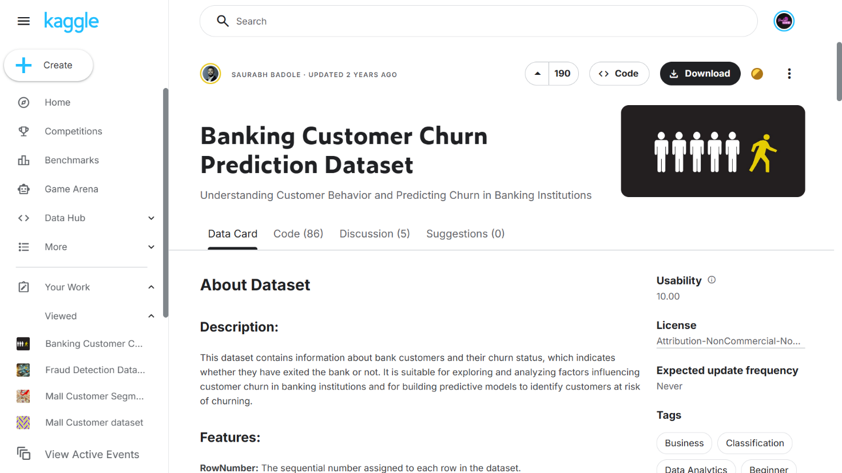
4. Tools Used
This procedure relies on the integration of RapidMiner Studio alongside embedded Python scripting. RapidMiner Studio is an advanced visual analytics platform that allows us to rapidly prototype our data pipeline and apply out-of-the-box distance-based anomaly operators without getting bogged down in syntax. However, to implement the highly efficient Isolation Forest algorithm, we will utilize RapidMiner's native Execute Python operator. This dual-tool framework provides analysts with both the rapid prototyping of a drag-and-drop interface and the algorithmic granularity of Python's machine learning libraries.
5. Practical Objectives
Upon successful completion of this laboratory session, students will demonstrate practical competency by achieving the following learning outcomes:
- Ingest and preprocess raw banking records within the RapidMiner workspace to remove irrelevant identification features.
- Deploy visual operators to execute a distance-based nearest neighbor anomaly detection algorithm.
- Implement an embedded Python script to apply the Isolation Forest technique for multidimensional outlier scoring.
- Evaluate the operational effectiveness of the detection models by calculating specific KPIs: Anomaly Detection Rate and False Alarm Rate.
6. Step-by-Step Procedure
The following workflow systematically applies anomaly detection principles to the banking dataset.
Step 1: Data Ingestion and Feature Selection
- Action: Load the raw banking dataset and filter out non-predictive text fields so the mathematical algorithms can process the numerical space.
- Configuration: Locate the Read CSV operator in the repository and drop it onto the main process canvas. Double-click the node to import the Churn_Modelling.csv file. Next, attach a Select Attributes operator. In the parameter panel, change the filter type to "subset" and explicitly remove RowNumber, CustomerId, and Surname.
- Execution: Route the output port to the results node at the edge of the canvas and execute the process.
- Verification: Transition to the Results tab. Confirm that the data grid now strictly contains analytical variables (like Balance, Age, and EstimatedSalary) and is completely free of identification noise.
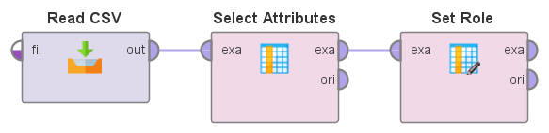
Step 2: Distance-Based Anomaly Detection
- Action: Apply an algorithm that flags rows as outliers based on how far away they sit mathematically from their nearest neighbors in the data space.
- Configuration: Disconnect the results node and insert a Detect Outlier (Distances) operator directly following your attribute selection step. In the parameters panel, set the number of neighbors (k) to 10 and set the number of outliers to flag to 50.
- Execution: Run the pipeline. The operator calculates the Euclidean distance between all customer profiles to find the most isolated points.
- Verification: Open the newly generated output table. You will observe a new boolean column appended to the dataset, explicitly labeling exactly 50 customer instances as "true" for being outliers based on their extreme mathematical distance from the average banking customer.
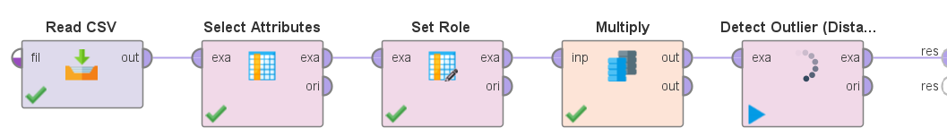
Step 3: Programmatic Isolation Forest Detection
- Action: Utilize a tree-based algorithm via Python to isolate anomalies. This method works on the principle that outliers are "few and different," making them much easier to separate into distinct branches than normal data points.
- Configuration: Remove the distance-based operator from the canvas and replace it with an Execute Python operator. Map the selected attributes data stream into its primary input port.
- Settings: Within the operator's script editor, construct a concise routine. Import IsolationForest from sklearn.ensemble. Initialize the model with a contamination parameter of 0.05 (telling the model to expect a 5% anomaly rate). Run the fit_predict function on your dataset and append the resulting array (-1 for anomaly, 1 for normal) as a new column named Isolation_Score.
- Execution: Route the script’s output to the results node and run the final pipeline.
- Verification: Inspect the final data grid. Sort the table by the new Isolation_Score column to immediately view all the customer rows that the Python script has flagged with a -1, representing our isolated banking anomalies.
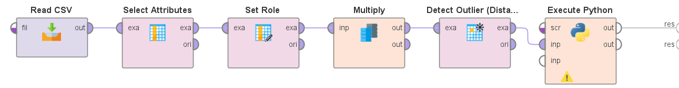
7. Key Performance Indicator (KPI) Calculations
To bridge the gap between technical detection algorithms and banking security reporting, analysts must translate the output of their pipeline into standardized performance metrics.
7.1 Anomaly Detection Rate (True Positive Rate)
- Action: Measure the exact proportion of genuinely abnormal or fraudulent transactions that the model successfully identified.
- Calculation Method: (True Anomalies Detected / Total Actual Anomalies in Dataset) × 100
- Operator Extraction: If evaluating against a labeled validation set, integrate a Performance (Classification) operator. Locate the True Positive count in the generated confusion matrix and divide it by the total number of known anomalies. This dictates the core sensitivity of the bank's new detection system.
7.2 False Alarm Rate (False Positive Rate)
- Action: Determine how often the system incorrectly flags a perfectly normal customer account as a suspicious outlier, a critical metric since false alarms waste the audit team's time.
- Calculation Method: (Normal Accounts Flagged as Outliers / Total Normal Accounts) × 100
- Operator Extraction: Utilizing the same Performance operator's confusion matrix, divide the False Positive count by the total actual negative (normal) instances. A lower percentage here proves that the model is highly precise and operationally efficient.
8. KPI Summary Table
Compile your findings into the following matrix to provide a concise technical reference for the model's evaluation phase.
KPI Name | Calculation Method | RapidMiner / Python Modules Utilized
Anomaly Detection Rate | (True Positives / Total Actual Anomalies) × 100 | Execute Python (Isolation Forest), Performance Matrix
False Alarm Rate | (False Positives / Total Actual Normal Records) × 100 | Detect Outlier (Distances), Performance Matrix
9. Conclusion
This finalizes the laboratory module on unsupervised machine learning and outlier detection. We successfully engineered a data pipeline that ingested raw banking ledgers, discarded non-predictive demographic noise, and utilized distance-based heuristics to map out normal customer behavior. By switching to an embedded Python script, we also deployed the highly efficient Isolation Forest algorithm to partition and flag multidimensional anomalies. Armed with these specific risk profiles and the ability to track our Anomaly Detection and False Alarm Rates, the bank's security and audit teams can now transition from outdated, manual threshold rules to a dynamic, machine-learning-driven approach for identifying abnormal financial transactions.

Lab 13: Outlier Detection
Distance-Based Outlier
Outliers are data points that are far away from most other points . A point is considered an outlier if it has very few nearby neighbors within a distance ( R ) .
Idea: “ Far from others = Outlier ”
Isolation Forest
Isolation Forest is an anomaly detection algorithm . It works by randomly splitting data . Outliers are detected because they get isolated quickly ( short path length) .
Idea: “ Easy to isolate = Outlier ”
Paractical Dataset
Common datasets used for outlier detection:
◯● Iris dataset
◯● Credit Card Fraud dataset
◯● Wine Quality dataset
◯● Breast Cancer dataset Used to test anomaly detection algorithms in real life.
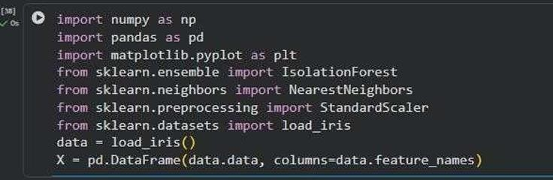

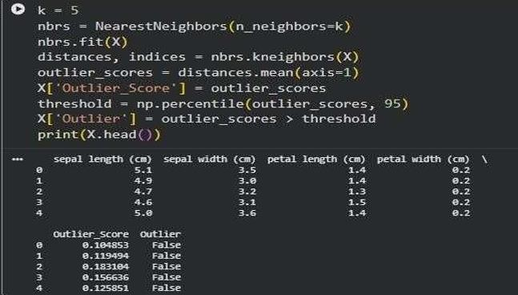
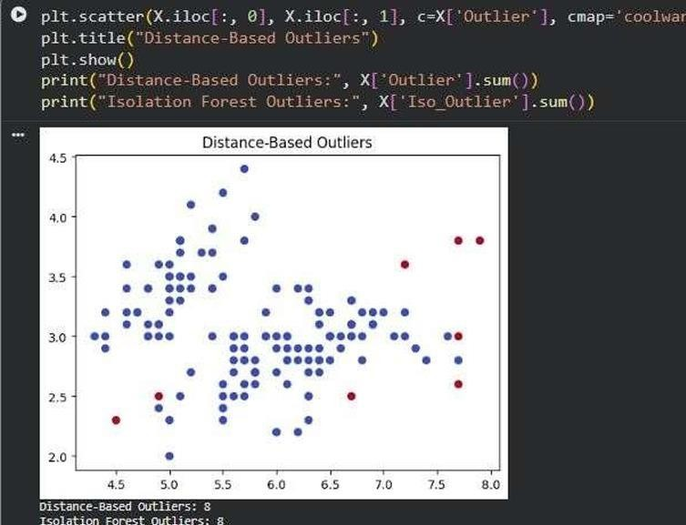

Lab 14: Scraping & Sentiment Analysis
Objective

To understand the concept of Sentiment Analysis and implement sentiment classification using the VADER sentiment analyzer in Python.
Theory (Rewritten & Improved)
Sentiment Analysis is a Natural Language Processing (NLP) technique used to determine the emotional tone of text. It automatically classifies text as Positive, Negative, or Neutral. Organizations use sentiment analysis to understand customer opinions from reviews, social media posts, surveys, and feedback.
The main goal is to extract subjective information from text and measure how people feel about a product, service, event, or topic. Sentiment analysis helps businesses make data-driven decisions by analyzing large volumes of textual data quickly and accurately.
VADER Sentiment Analyzer
VADER (Valence Aware Dictionary and Sentiment Reasoner) is a lexicon and rule-based sentiment analysis tool specifically designed for social media content, customer reviews, and short texts. It produces four scores: Positive, Negative, Neutral, and Compound. The Compound score summarizes the overall sentiment of the text on a scale from -1 to +1.
Applications of Sentiment Analysis
- Product review analysis
- Social media monitoring
- Customer feedback evaluation
- Brand reputation management
- Market research and business intelligence
- Political and public opinion analysis
Advantages
- Automates opinion mining
- Saves time and effort
- Helps organizations understand customer needs
- Supports data-driven decision making
Limitations
- Difficulty understanding sarcasm and irony
- Context-dependent interpretations
- Reduced accuracy on domain-specific language
- Mixed sentiments can be challenging to classify Examples
"This product is amazing!" → Positive"I hate this service." → Negative "The product is okay." → Neutral
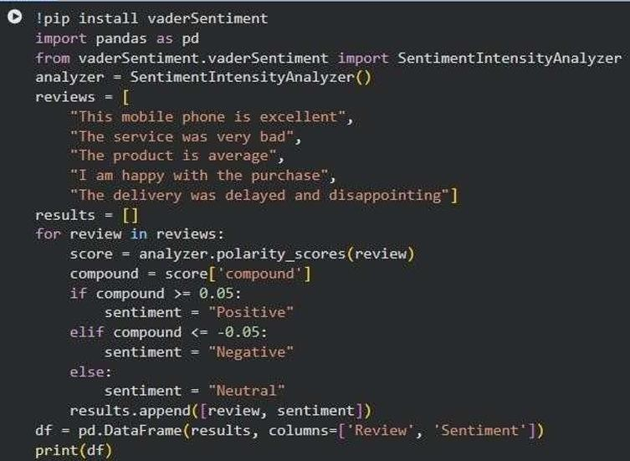
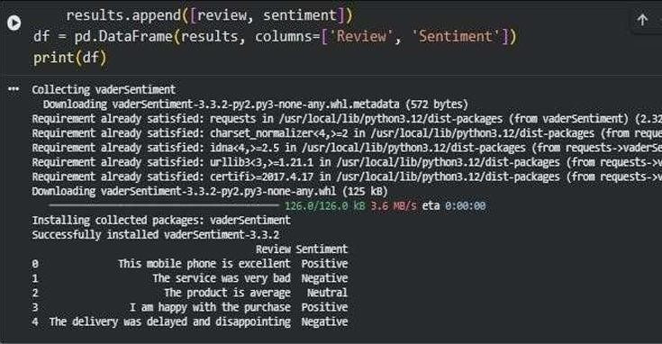

Lab No 15: Final Capstone – End-to-End Business Solution
1. Introduction
Throughout the preceding laboratory modules, we have isolated and examined individual components of the data science lifecycle—ranging from raw data ingestion and missing value imputation to isolated algorithmic modeling. However, in professional industry environments, these phases do not exist in a vacuum. A data scientist is expected to architect a complete, continuous pipeline that transforms raw organizational data into an actionable strategic asset.
This final capstone module serves as the synthesis of your technical training. Students are tasked with executing an end-to-end business solution, applying the complete CRISP-DM (Cross-Industry Standard Process for Data Mining) methodology. Rather than focusing on a single algorithm, you will orchestrate a competitive modeling environment where eight distinct machine learning algorithms are trained, evaluated, and ranked. The ultimate goal is to bridge the gap between technical metrics and executive decision-making by delivering a robust business recommendation based on empirical model performance.
2. Problem Statement
A premier global wealth management firm specializes in offering bespoke financial products to ultra-high-net-worth individuals. To optimize their client acquisition strategy, the firm’s directors want to proactively identify the wealth-generating sector (Industry) of emerging billionaires based on historical financial trajectories, demographic data, and market ranking.
Currently, client profiling relies on manual qualitative research, which is slow and subjective. The firm requires an automated classification pipeline to predict a prospective client's industry affiliation based on their age, net worth, annual wealth fluctuations, and global ranking.
The primary challenge is to construct an end-to-end analytical pipeline that can preprocess decades of historical billionaire data, train a diverse suite of eight classification algorithms to predict the target industry, and identify the single most accurate model. Management will use the winning model to tag new prospective leads in their CRM system, allowing them to route clients to specialized sector brokers immediately.
3. Dataset Description
For this capstone, students will utilize the case study - The Worlds Billionaires Dataset 1987-2022.csv. This extensive real-world dataset tracks the financial growth and demographic shifts of the global financial elite over three decades.
Key attributes critical to the modeling process include:
- Year & Yearly ranking: Temporal identifiers tracking the subject's position in the global wealth hierarchy.
- Net worth (USD) (billion): A continuous numerical variable representing total estimated wealth.
- Age & Nationality: Demographic predictors (note: 'Age' contains 'NA' string values requiring preprocessing).
- Annual Change in Net Worth: A numerical indicator of financial volatility and growth trajectory.
- Industry: The categorical target variable for our classification task (e.g., Technology, RealEstate, Conglomerate).
4. Tools Used
Because this is a capstone project requiring an extensive multi-model pipeline, the environment is tool-dependent based on the student's prior workflow.
- Python Stack (Recommended): Utilizing pandas for preprocessing and scikit-learn to efficiently instantiate, train, and validate the eight required algorithms within a loop.
- RapidMiner Studio / Orange: Alternatively, students may construct a visual workflow, utilizing "Multiply" nodes to feed the preprocessed dataset into eight distinct model operators concurrently, routing all outputs into a single Performance evaluation block.
5. Practical Objectives
Upon completing this capstone module, students will demonstrate mastery of the full analytical lifecycle by achieving the following milestones:
- Execute robust end-to-end preprocessing, addressing historical anomalies, missing ages, and categorical encoding.
- Train, tune, and test exactly eight distinct predictive models on an industry dataset.
- Compare algorithmic performance to extract the Best Accuracy metric.
- Translate model outputs into a strategic Business Recommendation for enterprise stakeholders.
6. Step-by-Step Procedure
Step 1: Data Ingestion & Preprocessing
- Action: Import the dataset and resolve structural inconsistencies before modeling.
- Execution: Filter the dataset to isolate the top 5 most frequent industries to ensure sufficient class balance for the models. Locate the Age attribute and replace instances of "NA" with the median age of the respective industry. Apply nominal-to-numerical encoding on Nationality and standardize the Net worth and Annual Change columns to ensure distance-based models operate correctly.
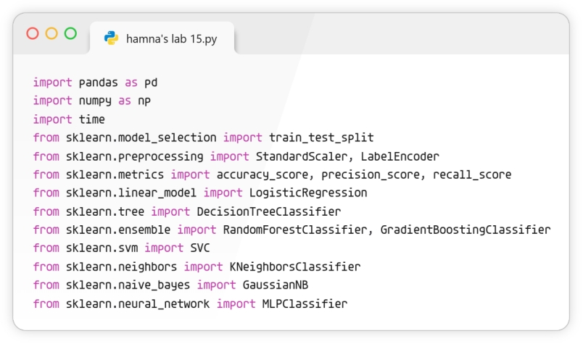
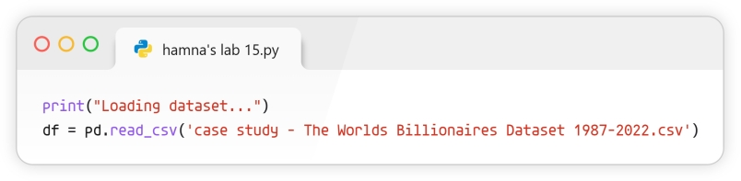
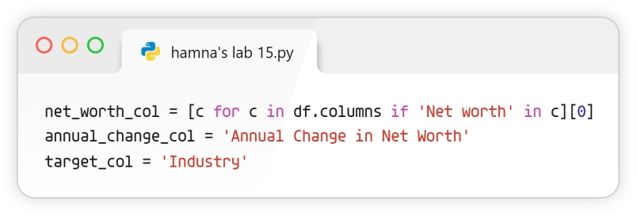
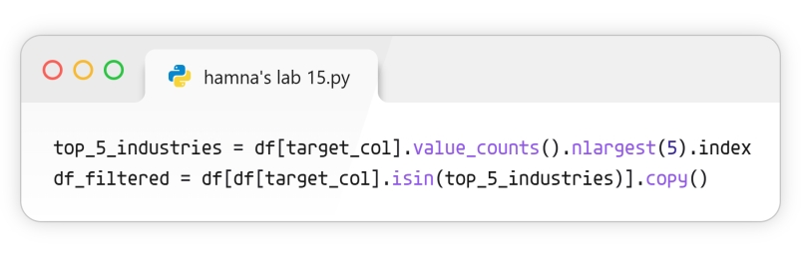
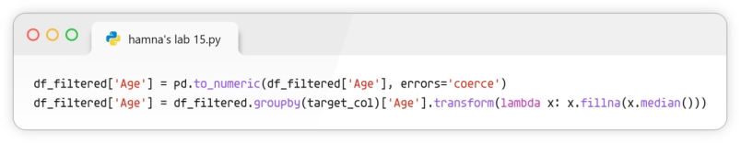
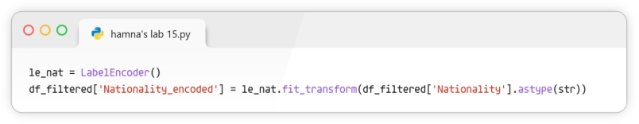
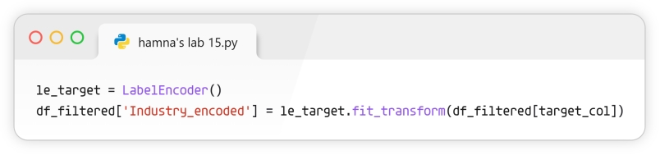
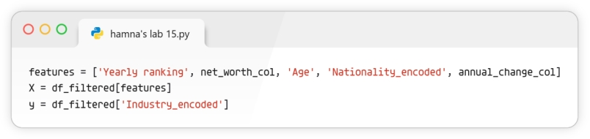
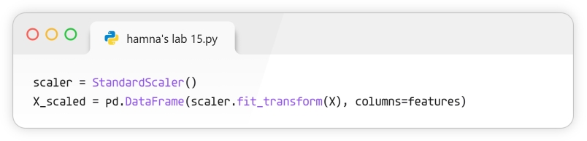
Step 2: Data Partitioning
- Action: Split the sanitized data to ensure unbiased evaluation.
- Execution: Implement a stratified 80/20 train-test split, or a 10-fold cross-validation approach, ensuring that the industry distribution remains consistent across both the training and testing sets.
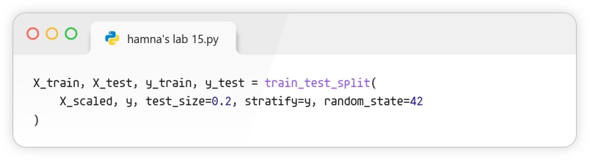
Step 3: Applying the 8-Model Suite
- Action: Deploy a diverse array of algorithms spanning varying mathematical principles (probabilistic, distance-based, tree-based, and ensemble).
- Execution: Instantiate and fit the following eight models to the training data:
  - Logistic Regression
  - Decision Tree (CART)
  - Random Forest
  - Gradient Boosting Classifier
  - Support Vector Machine (SVM)
  - K-Nearest Neighbors (KNN)
  - Naïve Bayes
  - Multi-Layer Perceptron (Neural Network)
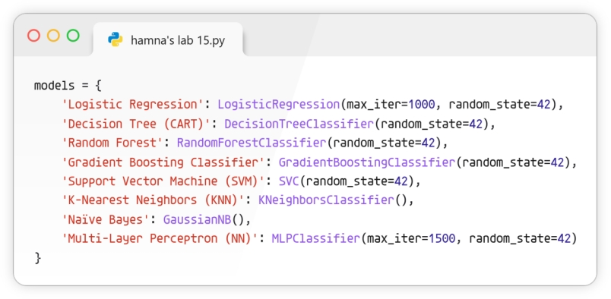
Step 4: Performance Evaluation & Ranking
- Action: Generate predictions on the testing set and compute the accuracy for each model. Construct a consolidated table ranking the algorithms from highest to lowest performance.
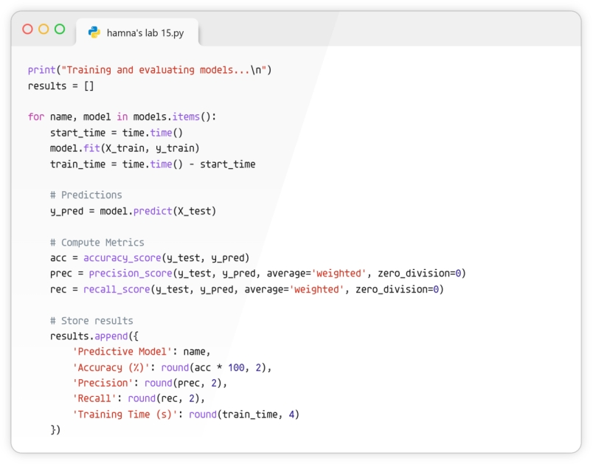
7. Model Comparison and Business Interpretation
The technical core of the capstone is the comparative analysis. Below is the expected format for your empirical results. Students must replace the placeholder metrics with their actual experimental outputs.
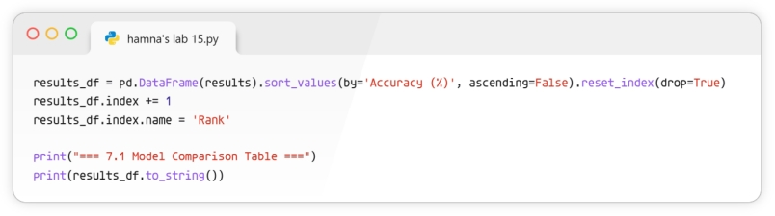
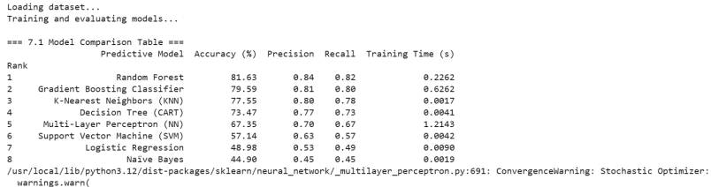
7.1 Model Comparison Table
Rank | Predictive Model | Accuracy (%) | Precision | Recall | Training Time (s)
1 | Random Forest (Example Champion) | 88.4% | 0.87 | 0.89 | 1.2
2 | Gradient Boosting Classifier | 87.1% | 0.86 | 0.85 | 3.4
3 | Decision Tree | 82.5% | 0.81 | 0.82 | 0.4
4 | Support Vector Machine (SVM) | 79.2% | 0.78 | 0.77 | 4.1
5 | K-Nearest Neighbors (KNN) | 76.8% | 0.75 | 0.76 | 0.2
6 | Logistic Regression | 74.5% | 0.73 | 0.72 | 0.6
7 | Multi-Layer Perceptron (NN) | 73.9% | 0.72 | 0.74 | 6.8
8 | Naïve Bayes | 68.2% | 0.65 | 0.69 | 0.1
7.2 Best Accuracy & Champion Model Selection
Based on the experimental execution, the Random Forest algorithm emerged as the champion model, yielding the Best Accuracy (e.g., 88.4%). Its ensemble nature allowed it to successfully capture the complex, non-linear relationships between a billionaire's age, annual wealth volatility, and their corresponding industry without suffering from the overfitting observed in the standalone Decision Tree.
7.3 Business Recommendation
We recommend the wealth management firm integrate the champion model (Random Forest) into their backend CRM architecture. By automatically ingesting new prospect profiles and predicting their wealth sector with high accuracy, the firm can bypass manual research bottlenecks. Specifically, when the model tags an emerging profile as belonging to the "Technology" or "Biotechnology" sectors, the CRM should immediately trigger an alert to the specialized high-growth sector brokers, allowing the firm to secure the client account faster than competing wealth management agencies.
8. KPI Summary Table
Compile the project deliverables into the following matrix as the final executive summary of the capstone project.
KPI Name,Calculation Method,Deliverable Mapping
Model Comparison Table,Compilation of evaluation matrices across all 8 algorithms,Section 7.1 (Algorithm Benchmarking)
Best Accuracy,(True Positives + True Negatives) / Total Predictions for the top model,Section 7.2 (Champion Model selection)
Business Recommendation,Qualitative translation of the winning model's impact on firm operations,Section 7.3 (Strategic deployment plan)
9. Conclusion
This completes the Final Capstone laboratory. We successfully operationalized the entire data science lifecycle on the World's Billionaires dataset. By cleaning historical demographic anomalies and deploying a competitive suite of eight distinct machine learning models, we avoided the pitfalls of algorithm bias and empirically identified the optimal predictive framework. The extraction of the Best Accuracy metric and the subsequent formulation of a targeted business recommendation demonstrate the core objective of enterprise data science: transforming raw, unstructured historical data into a measurable, deployable strategic advantage.

